

Wollo University

Kombolcha Institute of Technology

College of Informatics

Department of Software Engineering

We here by submitted a project in partial fulfilment of bachelor Degree in Software Engineering

Title: E-Learning Management system

Submitted to the departments of Software Engineering

Name ID

Meseret Mezgebu 1349/16

Elsabet Admasu 0658/16

Rehima Ali 1619/16

Meron Hassen 1339/16

Submission date: January 4/2026

**Discrimination**

We hereby declare that our project in titled E-Learning Edu platform is original and not submitted/Published by any individual/ Organization.

**Group Members**

**S.N. Name List ID Number sign**

1 Mseret Mezgebu WOUR/1349/16 \_\_\_\_\_\_\_\_

2. Elsabet Admasu WOUR/0658/16 \_\_\_\_\_\_\_\_

1. Rehima Ali WOUR1619/16 \_\_\_\_\_\_\_\_

4. Meron Hassen WOUR/1339/16 \_\_\_\_\_\_\_\_

**Advisor**

Name: Mr.Nurye T (Msc)

Date of submission: January 4/2026 Sign: \_\_\_\_\_\_\_\_\_\_

## 

## **Approval of the Board of Examiners**

We, the undersigned members of the Board of Examiners, have read, evaluated, and examined the final open defense presented by the students listed above. The project entitled: “Design and Implementation of an E-Learning Management System ” has been thoroughly assessed, and the candidates have successfully defended their work. This is therefore to certify that the project has been accepted in partial fulfillment of the requirements for the award of the Degree of Bachelor of Software Engineering.

\_\_\_\_\_\_\_\_\_\_\_\_\_\_\_\_\_\_\_\_\_\_ \_\_\_\_\_\_\_\_\_\_\_\_\_\_\_\_\_\_\_\_ \_\_\_\_\_\_\_\_\_\_\_\_\_\_\_\_\_\_

(Advisor) Signature Date

\_\_\_\_\_\_\_\_\_\_\_\_\_\_\_\_\_\_\_\_\_\_ \_\_\_\_\_\_\_\_\_\_\_\_\_\_\_\_\_\_\_\_ \_\_\_\_\_\_\_\_\_\_\_\_\_\_\_\_\_\_

(Chairperson) Signature Date

\_\_\_\_\_\_\_\_\_\_\_\_\_\_\_\_\_\_\_\_\_\_ \_\_\_\_\_\_\_\_\_\_\_\_\_\_\_\_\_\_\_\_\_ \_\_\_\_\_\_\_\_\_\_\_\_\_\_\_\_\_\_

(Examiner 1) Signature Date

\_\_\_\_\_\_\_\_\_\_\_\_\_\_\_\_\_\_\_\_\_\_ \_\_\_\_\_\_\_\_\_\_\_\_\_\_\_\_\_\_\_\_\_ \_\_\_\_\_\_\_\_\_\_\_\_\_\_\_\_\_\_

(Examiner 2) Signature Date

\_\_\_\_\_\_\_\_\_\_\_\_\_\_\_\_\_\_\_\_\_\_ \_\_\_\_\_\_\_\_\_\_\_\_\_\_\_\_\_\_\_\_\_ \_\_\_\_\_\_\_\_\_\_\_\_\_\_\_\_\_\_

(Examiner 3) Signature Date

## 

## ****Summary****

Our project, the **E-Learning Management System**, is aimed at addressing the challenges and limitations commonly associated with traditional teaching and learning processes, such as manual course management, limited access to learning materials, inefficient assessment methods, and poor communication between students, instructors, and administrators.

The system is developed at **Wollo University**, specifically for the **Software Engineering Department**, with the goal of providing a centralized, web-based platform that supports online learning, course management, assessments, communication, and academic administration.

Through the use of modern web technologies and automation, the proposed system aims to improve learning accessibility, enhance student engagement, reduce administrative workload, and ensure efficient management of academic resources. The platform enables students to access learning materials anytime and anywhere, allows instructors to manage courses and evaluations effectively, and provides administrators with tools for system monitoring and reporting.

We expect that the E-Learning Management System will significantly benefit students, instructors, and academic administrators by improving the overall quality and efficiency of the learning process. Furthermore, we believe that the system has the potential to be expanded and adopted beyond the immediate academic environment, contributing to the advancement of digital education in the wider community.

## 

## ****Acknowledgement****

First and foremost, we would like to express our deepest gratitude to **Almighty God** for granting us the strength, patience, and wisdom to successfully complete this project. The completion of this work would not have been possible without His guidance and blessings.

We would like to extend our sincere appreciation to **Mr. Nurye T. (MSc)**, our project advisor, for his continuous guidance, constructive feedback, encouragement, and professional support throughout the development of this project. His extensive knowledge and experience in software engineering played a vital role in shaping the design and implementation of the **E-Learning Management System**, and his mentorship greatly contributed to the success of this work.

We are also highly grateful to the faculty members and staff of the **Software Engineering Department at Wollo University** for providing us with the necessary academic support, resources, and learning environment. Their dedication to teaching and mentoring has been invaluable throughout our academic journey and during the execution of this project.

Furthermore, we would like to thank the academic staff and students who cooperated with us by sharing their insights, requirements, and feedback related to online learning systems. Their cooperation and willingness to provide information significantly helped us in understanding real-world educational challenges and in designing a more effective and practical E-Learning platform.

Finally, we would like to express our heartfelt thanks to our **families and friends** for their continuous support, encouragement, and motivation throughout the course of this project. Their patience, understanding, and moral support were crucial in helping us overcome challenges and remain focused until the successful completion of this work.

## ****Acronyms & Abbreviations****

|  |  |
| --- | --- |
| **Acronyms** | **Description** |
| ELMS | E-Learning Management System |
| WU | Wollo University |
| FR | Functional Requirement |
| SRS | System Requirement Specification |
| NFR | Non-Functional Requirement |
| LMS | Learning Management System |
| Auth | Authentication |
| RBAC | Role-Based Access Control |
| Course-Mgmt | Course Management |
| Lesson-Mgmt | Lesson Management |
| Quiz-Mgmt | Quiz and Assessment Management |
| User-Profile | User Profile Management |
| DB | Database |
| Admin | System Administrator |
| St | Student |
| Tch | Teacher / Instructor |
| Pmnt | Payment / Transaction |
| Notif | Notification System |

## ****Définitions****

**Contact details:** Information related to a user, such as email address, phone number, or other ways to communicate within the system.

**Stakeholders:** Individuals or groups who have an interest or involvement in the operations, decisions, and outcomes of the E-Learning Management System, such as students, teachers, administrators, and technical support staff.

**Proposed system:** The E-Learning Management System that is being developed to support online teaching, learning, assessment, and academic administration.

**Existing system:** Any current or pre-existing software, platform, or manual process that is currently being used to manage courses, lessons, student records, assessments, and other educational activities.

**Functional requirements:** The features, capabilities, and operations that the E-Learning Management System must possess in order to achieve its intended purpose, such as course creation, online assessments, progress tracking, and gamification.

**Non-functional requirements:** The qualities or characteristics that the system must meet, such as usability, performance, scalability, security, reliability, and accessibility.

**Activity diagram:** A visual representation of the different steps or activities involved in performing a process within the E-Learning system, such as course enrollment, lesson access, assignment submission, or grading.

**Sequence diagram:** Illustrates the order and timing of interactions between system components and users, such as students, teachers, and administrators, during processes like submitting assignments, evaluating quizzes, or processing payments.

**Use case diagram:** A visual representation of the functional requirements of the system from the perspective of its users (actors), showing how students, teachers, and administrators interact with various system features.

### TABLE CONTENT **TABLE OF CONTENTS**

**PRELIMINARY PAGES**

**Approval of the Board of Examiners** ..................................................................... ||

**Summary** ........................................................................................................................... ||

**Acknowledgement** .......................................................................................................... ||

**Acronyms & Abbreviations** .......................................................................................... ||

**Definitions** ......................................................................................................................... ||

**CHAPTER ONE: INTRODUCTION** ................................................................................... **3**

1.1 Introduction ................................................................................................................ 3

1.2 Background of the Study ............................................................................................ 3

1.3 Statement of the Problem .......................................................................................... 4

1.4 Proposed System ........................................................................................................ 4

1.5 Objectives of the System ............................................................................................ 5

1.5.1 General Objective ......................................................................................... 5

1.5.2 Specific Objectives ....................................................................................... 5

1.6 Scope of the System ................................................................................................... 5

1.7 Limitations of the System .......................................................................................... 6

1.8 Significance of the Study ............................................................................................ 6

1.9 Methodology .............................................................................................................. 6

1.9.1 Data Collection Methods .............................................................................. 6

1.9.2 System Development Methodology .............................................................. 6

1.10 Feasibility Study ....................................................................................................... 9

1.10.1 Technical Feasibility ................................................……………............... 9

1.10.2 Economic Feasibility ....................................………………..................... 9

1.10.3 Operational Feasibility ................................................................................ 9

**CHAPTER TWO: SYSTEM REQUIREMENTS SPECIFICATION** .................................. **10**

2.1 System Overview ..................................................................................................... 10

2.2 User Classes and Characteristics ............................................................................. 10

2.3 Assumptions and Dependencies ............................................................................. 19

2.4 Specific Requirements ............................................................................................. 20

2.4.1 Functional Requirements ............................................................................ 20

2.4.2 Non-Functional Requirements .................................................................... 21

2.5 External Interface Requirements ............................................................................. 22

2.5.1 User Interface .............................................................................................. 22

2.5.2 Software Interface ....................................................................................... 23

2.5.3 Communication Interface ........................................................................... 24

**CHAPTER THREE: REQUIREMENT ANALYSIS MODELING** ..................................... **25**

3.1 Overview of the Analysis Model .............................................................................. 25

3.2 System Use Case Diagram ....................................................................................... 25

3.2.1 Use Case Scenarios ..................................................................................... 26

3.2.2 Use Case Model .......................................................................................... 28

3.2.3 Use Case Descriptions ................................................................................ 30

**CHAPTER FOUR: SYSTEM DESIGN** ............................................................................. **34**

4.1 Overview .......................................................................................................... 44

4.1.1 Design Considerations and Purposes .......................................................... 45

4.1.2 Design Goals ............................................................................................... 46

4.8 References ................................................................................................................ 79

### **LIST OF TABLES**

**Table 1.1: Acronyms & Abbreviations** ........................................................................ 2

**Table 2.1: Functional Requirements (FR)** ................................................................... 20

**Table 2.2: Non-Functional Requirements (NFR)** ........................................................ 21

### **LIST OF FIGURES**

**Figure 3.1: Use Case Model** .......................................................................................... 28

**Figure 3.2: Sequential Model** ........................................................................................ 32

**Figure 3.3: Activity Diagram Model** ............................................................................ 33

**CHAPTER ONE: INTRODUCTION**

**1.1 Introduction**

Education is a fundamental pillar for the development of individuals, communities, and nations. Traditionally, education has been delivered through face-to-face classroom instruction where teachers and students must be physically present at the same time and location. However, this approach has limitations in terms of flexibility, accessibility, and scalability.

With the rapid advancement of **Information and Communication Technology (ICT)**, the education sector has undergone significant transformation. Digital technologies such as the internet, cloud computing, and web applications have enabled learning to occur beyond the physical classroom. This transformation has led to the emergence of **E-Learning systems**, which allow learners to access educational content anytime and anywhere.

An **E-Learning Management System (ELMS)** is a web-based platform that supports teaching and learning activities electronically. It provides a centralized environment where students, instructors, and administrators can interact, share resources, conduct assessments, track academic progress, and manage educational processes efficiently. The system removes time and location constraints, making education more inclusive and flexible.

**1.2 Background of the Study**

Higher education institutions are increasingly adopting digital technologies to improve teaching quality and learning outcomes. Traditional learning systems often rely on printed materials, manual record-keeping, and in-person interactions, which can lead to inefficiencies such as delayed feedback, lost records, and limited access to learning resources.

Additionally, modern learners demand interactive, self-paced, and technology-supported learning experiences. The growing need for distance education, especially due to factors such as geographical barriers and busy schedules, has further highlighted the importance of digital learning platforms.

An E-Learning Management System addresses these challenges by offering:

* Centralized access to learning materials
* Automated academic management
* Continuous communication between students and instructors
* Real-time feedback and progress tracking

Thus, the background of this study is rooted in the need to modernize education delivery using technology-driven solutions.

**1.3 Statement of the Problem**

Despite its importance, the traditional education system faces several critical challenges:

1. **Dependence on physical classrooms**  
   Learning is restricted to specific locations and schedules, making it difficult for working students or distant learners to participate.
2. **Limited access to learning resources**  
   Students can only access materials during class hours or from physical libraries.
3. **Manual academic processes**  
   Assessments, grading, and record management are often handled manually, increasing errors and inefficiency.
4. **Delayed feedback**  
   Students may wait long periods to receive feedback on assignments and exams.
5. **Poor communication**  
   Interaction between students and instructors is limited outside class time.
6. **Lack of support for distance learning**  
   Traditional systems are not designed for self-paced or remote education.

These problems create the need for a reliable, automated, and web-based E-Learning Management System.

**1.4 Proposed System**

The proposed **E-Learning Management System** is a web-based solution designed to enhance and automate the teaching and learning process.

The system provides the following features:

* **Online course creation and management**  
  Teachers can create, update, and manage courses digitally.
* **Digital lesson delivery**  
  Learning materials such as videos, documents, and presentations are uploaded and accessed online.
* **Online assessments**  
  Quizzes, assignments, and exams are conducted electronically.
* **Gamification features**  
  Students earn points, rankings, and badges to increase motivation and engagement.
* **Secure payment system**  
  Students can pay for premium courses using secure online payment gateways.
* **Progress tracking**  
  Student performance and participation are monitored and reported automatically.

This system ensures efficiency, transparency, and accessibility in education delivery.

**1.5 Objectives of the System**

**1.5.1 General Objective**

The main objective of this project is to **design and develop an E-Learning Management System** that improves educational accessibility, quality, and efficiency through digital technology.

**1.5.2 Specific Objectives**

The specific objectives include:

* Providing students with **online access to learning materials**
* Supporting **course, lesson, and assessment management**
* Implementing **secure authentication and authorization**
* Integrating **gamification techniques** to motivate learners
* Supporting **online payment** for premium courses
* Generating **academic progress and performance reports**

These objectives guide the design and implementation of the system.

**1.6 Scope of the System**

The scope defines what the system will cover and what functionalities are included.

The E-Learning Management System includes:

* User registration and **role-based access control**
* Course and lesson creation and management
* Online quizzes and assignments
* Gamification features such as points, rankings, and badges
* Payment processing for paid courses
* Notifications and internal messaging
* Reporting and analytics for academic performance

The system focuses on web-based learning and does not include offline or mobile-only applications in its initial version.

**1.7 Limitations of the System**

Despite its advantages, the system has certain limitations:

* Requires **stable internet connectivity**
* Limited to **web-based access only**
* Supports **only one language** in the initial release

These limitations may be addressed in future system upgrades.

**1.8 Significance of the Study**

The proposed system is significant to various stakeholders:

* **Students** benefit from flexible, interactive, and self-paced learning.
* **Teachers** benefit from simplified course management and automated assessments.
* **Educational institutions** benefit from reduced administrative workload and improved educational quality.

Overall, the system enhances modern digital education practices.

**1.9 Methodology**

This section explains **how the system was studied, analyzed, designed, and developed**. The methodology provides a systematic approach that ensures the final system meets user requirements, is reliable, and is practical for real-world use.

**1.9.1 Data Collection Methods**

Data collection is a critical phase in system development because it helps the developer understand the real problems, user expectations, and operational environment of the system. In this study, multiple data collection techniques were used to ensure accuracy and completeness.

**a) Interviews with Students and Instructors**

Interviews were conducted with students and instructors to gather first-hand information about their learning and teaching experiences.  
Students were asked about:

* Difficulties accessing learning materials
* Challenges with assessments and feedback
* Preferences for online learning features

Instructors were asked about:

* Course delivery challenges
* Assessment management
* Communication with students

These interviews helped identify key system requirements such as online content access, automated grading, and messaging features.

**b) Observation of Existing Learning Processes**

Observation involved carefully studying how teaching and learning activities are currently performed in traditional and partially digital environments.  
This included:

* Classroom teaching methods
* Manual assessment handling
* Record-keeping procedures

Through observation, inefficiencies such as delayed feedback and heavy administrative workload were identified. This information guided the design of automated features in the proposed system.

**c) Document Review of Similar Systems and Academic Materials**

Relevant documents such as:

* Existing e-learning system manuals
* Research papers
* Academic guidelines

were reviewed to understand best practices and standard functionalities. This helped ensure that the proposed system aligns with modern educational and technical standards.

**1.9.2 System Development Methodology**

The system was developed using a **structured System Development Life Cycle (SDLC)**. This approach divides system development into clear phases, ensuring quality and reliability.

**a) Requirement Analysis**

In this phase, all functional and non-functional requirements were identified and documented.  
Examples include:

* User registration and authentication
* Course management
* Online assessments
* Security requirements

This phase ensured that user needs were fully understood before design and implementation.

**b) System Design**

During system design, the overall structure of the system was planned. This includes:

* System architecture
* Database design
* User interface design

Design diagrams were created to show how different components interact.

**c) Implementation**

In the implementation phase, the system was developed using web technologies.  
This involved:

* Writing back-end and fronted code
* Integrating databases
* Implementing business logic

Each module was implemented according to the design specifications.

**d) Testing**

Testing ensures that the system works correctly and meets requirements.  
Types of testing include:

* Unit testing
* Integration testing
* User acceptance testing

Errors and bugs identified during testing were corrected before deployment.

**e) Deployment**

After successful testing, the system was deployed to a live server where users could access it via a web browser.

**f) Maintenance**

Maintenance involves:

* Fixing reported issues
* Updating features
* Improving system performance

This ensures long-term system reliability.

**1.10 Feasibility Study**

A feasibility study evaluates whether the proposed system is practical and viable before full implementation.

**1.10.1 Technical Feasibility**

The system is technically feasible because it uses **proven and widely adopted web technologies**, including:

* Web servers
* Databases
* Programming frameworks

These technologies are stable, secure, and supported by large developer communities, reducing technical risks.

**1.10.2 Economic Feasibility**

From an economic perspective, the system is cost-effective.  
It reduces:

* Printing costs
* Manual administrative labor
* Physical infrastructure expenses

Although initial development costs exist, long-term operational savings justify the investment.

**1.10.3 Operational Feasibility**

The system is operationally feasible because:

* It has a simple and intuitive interface
* Users require minimal training
* It fits well within existing educational workflows

This ensures smooth adoption by students and staff.

**CHAPTER TWO: SYSTEM REQUIREMENTS SPECIFICATION**

**2.1 System Overview**

The E-Learning Management System is a centralized web-based application designed to manage online education activities. It supports teaching, learning, assessment, communication, and administration in a single integrated platform.

**2.2 User Classes and Characteristics**

**a) Student**

Students are the primary users who:

* Enroll in courses
* Access learning materials
* Take quizzes and assignments
* Earn points and track progress

**b) Teacher**

Teachers are responsible for:

* Creating and managing courses
* Uploading lessons and assessments
* Evaluating student performance
* Communicating with students

**c) Admin**

Admins manage system operations including:

* User management
* Content moderation
* Payment management
* System reporting

**2.3 Assumptions and Dependencies**

The system is developed under the following assumptions:

* Users have internet connectivity
* Users possess basic computer skills
* Payment gateway services are available
* These factors influence system functionality and performance.

**2.4 Specific Requirements**

**2.4.1 Functional Requirements**

|  |  |  |
| --- | --- | --- |
| **FR ID** | **Requirement** | **Description** |
| FR-1 | User Registration & Login | The system shall allow students and teachers to create accounts, authenticate using email and password, and reset forgotten passwords. |
| FR-2 | Role Management | The system shall support Student, Teacher, and Admin roles with role-based access control. |
| FR-3 | Course Management | Teachers shall create, update, and delete free or paid courses. |
| FR-4 | Lesson Management | Teachers shall upload lessons, assignments, and quizzes. Students shall access content and submit assignments. |
| FR-5 | Quiz & Exam Management | Teachers shall create quizzes; students shall attempt quizzes and receive scores. |
| FR-6 | Gamification | The system shall award points, rankings, and optional badges. |
| FR-7 | Discussion & Messaging | Users shall communicate via lesson discussions and optional private messages. |
| FR-8 | Progress Tracking | The system shall track student progress, scores, points, and payments. |
| FR-9 | Notifications | The system shall notify users of academic and payment-related events. |
| FR-10 | Search & Navigation | Users shall search and filter courses and learning materials. |
| FR-11 | Admin Dashboard | Admins shall manage users, content, payments, and reports. |
| FR-12 | Payment System | Students shall pay for premium courses using secure gateways. |

**2.4.2 Non-Functional Requirements**

|  |  |  |
| --- | --- | --- |
| **NFR ID** | **Category** | **Description** |
| NFR-1 | Security | Secure authentication, encrypted passwords, and protected payment data |
| NFR-2 | Performance | Fast response time with concurrent users |
| NFR-3 | Usability | Simple and user-friendly interface |
| NFR-4 | Reliability | High availability and data backup |
| NFR-5 | Scalability | Supports growth in users and content |
| NFR-6 | Maintainability | Modular and easy to update |
| NFR-7 | Compatibility | Works on major browsers |

**2.5 External Interface Requirements**

External Interface Requirements describe **how the system interacts with users, other software systems, and communication technologies**. These interfaces ensure that the E-Learning Management System works smoothly with people and external services.

**2.5.1 User Interface**

The **User Interface** is the part of the system that users directly interact with. It plays a critical role in system usability and user satisfaction.

The system provides a **responsive and user-friendly graphical interface** that adapts automatically to different screen sizes and devices such as:

* Desktop computers
* Laptops
* Tablets
* Smartphones

This is achieved using modern web design techniques such as responsive layouts.

### ****Key Characteristics of the User Interface****

1. **Simplicity**  
   The interface is designed to be simple and intuitive so that users with basic computer skills can easily navigate the system.
2. **Consistency**  
   Buttons, menus, colors, and layouts remain consistent throughout the system, reducing confusion.
3. **Accessibility**  
   Users can easily access courses, lessons, quizzes, and reports without unnecessary steps.
4. **Role-Based Views**
   * Students see enrolled courses, lessons, and progress.
   * Teachers see course management and grading tools.
   * Admins see dashboards and system reports.

### ****Example****

A student logs in using a mobile phone and can:

* View enrolled courses
* Watch lesson videos
* Take quizzes  
  without any layout distortion or difficulty.

**2.5.2 Software Interface**

The **Software Interface** defines how the E-Learning Management System communicates with other software components and external systems.

**1. Database Interface**

The system integrates with a **database management system** to store and retrieve data.

**Stored Data Includes:**

* User information (students, teachers, admins)
* Course and lesson content
* Quiz questions and results
* Payment records
* Progress and reports

The database ensures:

* Data consistency
* Data security
* Fast access to information

**Example**

When a student submits an assignment, the system stores:

* Student ID
* Assignment file
* Submission date
* Score (after evaluation)

**2. Payment Gateway Interface**

The system integrates with **secure online payment gateways** to support paid courses.

**Functions of the Payment Interface**

* Process student payments
* Verify successful transactions
* Record payment history
* Restrict access until payment is completed

**Security Measures**

* Encrypted payment communication
* No direct storage of sensitive card information

**Example**

When a student selects a premium course:

1. The system redirects to a payment gateway
2. Payment is processed securely
3. Course access is granted automatically upon success

**2.5.3 Communication Interface**

The **Communication Interface** defines how data is transmitted between users and the system over the network.

**HTTP/HTTPS Protocols**

The system uses:

* **HTTP** for basic communication
* **HTTPS** for secure communication

**Why HTTPS Is Important**

* Encrypts data during transmission
* Protects login credentials and personal data
* Prevents unauthorized access and data tampering

**Example**

When a user logs in:

* Username and password are encrypted
* Data is safely transmitted to the server
* Unauthorized interception is prevented

**CHAPTER THREE**

**REQUIREMENT ANALYSIS MODELING**

**3.1 Overview of the Analysis Model**

The requirement analysis model of the proposed **E-Learning Management System (ELMS)** is designed to identify, analyze, and clearly describe the functional behavior and interactions within the system. This model focuses on understanding how different users interact with the system and how various learning processes are executed.

The analysis model includes the following key components:

* **Use Case Diagrams**
* **Activity Diagrams**
* **Sequence Diagrams**

These modeling tools work together to provide a complete and structured understanding of the system’s behavior.

* **Use Case Diagrams** present a high-level view of the system’s functionalities and the interactions between users and the system.
* **Activity Diagrams** illustrate the flow of activities and learning processes within the system.
* **Sequence Diagrams** describe the sequence of interactions and message exchanges between system components over time.

Together, these diagrams help stakeholders understand how the E-Learning Management System operates, ensuring that system requirements are clear, consistent, and well-defined before implementation.

**3.2 System Use Case Diagram**

The **System Use Case Diagram** illustrates the interactions between users and the E-Learning Management System. It identifies system actors and the services they access based on their roles.

**Actors in the System**

* Student
* Teacher
* Administrator

Each actor interacts with the system through specific use cases that define their responsibilities and permissions

**3.2.1 Use Case Scenarios**

**A. User Registration Scenario**

**Scenario Description:**

* New users (students or teachers) access the E-Learning Management System through the web application.
* The user clicks on the **“Register”** button on the login page.
* The system displays a registration form requesting details such as full name, email address, contact number, and password.
* The user fills in the required information and submits the registration form.
* The system validates the entered information for completeness and correctness.
* If the information is valid, the system creates a new user account and displays a successful registration message.
* If invalid information is detected, the system displays appropriate error messages and prompts the user to correct the input.

This use case ensures secure and accurate user on boarding.

**B. User Login Scenario**

**Scenario Description:**

* Registered users access the system through the login page.
* The user enters login credentials such as email/username and password.
* The system verifies the credentials against the stored user database.
* If the credentials are correct, the system grants access and redirects the user to their respective dashboard based on their role (Student, Teacher, or Admin).
* If the credentials are incorrect, the system displays an error message and requests re-entry of valid credentials.

This scenario ensures secure authentication and role-based access.

**C. Course Management Scenario**

**Scenario Description:**

* A teacher logs into the system and accesses the **Course Management Dashboard**.
* The system displays options to create, update, or delete courses.
* The teacher selects **“Create Course”** and enters course details such as title, description, category, and course type (free or paid).
* The teacher uploads learning materials such as videos, documents, and assignments.
* The system validates the entered data and saves the course.
* The course becomes available to students for enrollment.

This scenario supports effective online course creation and management.

**D. Student Enrollment and Learning Scenario**

**Scenario Description:**

* A student logs into the system and browses available courses.
* The student selects a desired course.
* If the course is free, enrollment is granted immediately.
* If the course is paid, the student is redirected to the payment process.
* After successful enrollment, the student gains access to course lessons, quizzes, and assignments.
* The system tracks the student’s learning progress.

This use case enables flexible and self-paced learning.

**E. Online Assessment and Quiz Scenario**

**Scenario Description:**

* A teacher creates quizzes or assignments for a course.
* Students access the assessment through the course page.
* The student attempts the quiz and submits responses.
* The system automatically evaluates objective questions.
* Scores and feedback are generated and stored.
* Students can view results and performance history.

This scenario ensures efficient and automated assessment management.

**F. Payment Processing Scenario**

**Scenario Description:**

* A student selects a paid course.
* The system redirects the student to a secure payment gateway.
* The student completes the payment transaction.
* The system verifies the payment status.
* Upon successful payment, course access is granted.
* Payment details are stored for reporting purposes.

This scenario supports secure and reliable financial transactions.

**G. Discussion and Communication Scenario**

**Scenario Description:**

* Students and teachers access the discussion forum within a course.
* Users post questions, replies, and comments.
* The system stores and displays discussion threads.
* Teachers provide academic guidance through responses.

This scenario enhances interaction and collaborative learning.

**H. User Profile Management Scenario**

**Scenario Description:**

* A user logs into the system and accesses their profile.
* The user views personal information such as name, email, and role.
* The user updates profile details when necessary.
* The system validates and saves the changes.
* Updated information is reflected throughout the system.

This ensures accurate and up-to-date user information.

**3.2.2 Use Case Model**

The Use Case Model provides a structured view of all system interactions between users and the E-Learning Management System. It defines:

* System boundaries
* Actor responsibilities
* Functional services offered by the system

The model ensures that:

* All functional requirements are clearly identified
* User roles are well-defined
* System behavior aligns with user expectations

This model serves as a foundation for system design, implementation, and testing.

Use case model image

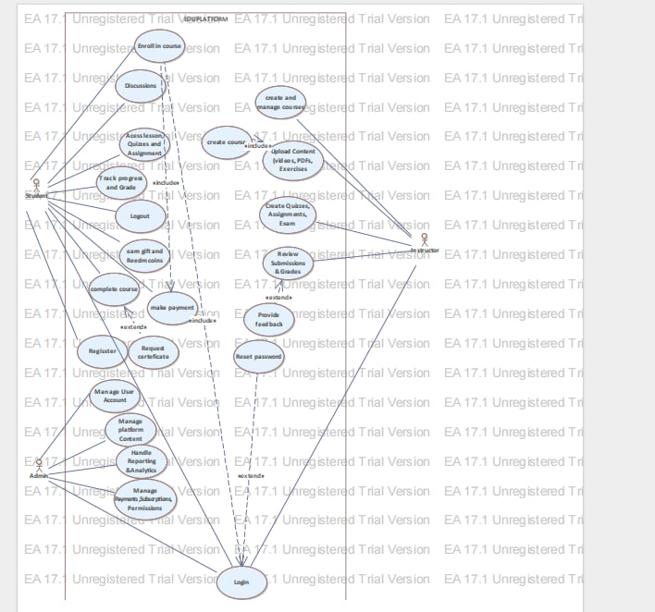

**3.2.3 Use Case Descriptions**

This section provides detailed descriptions of the major use cases of the **E-Learning Management System (ELMS)**. Each use case explains system behavior, actors involved, preconditions, post conditions, normal flow, alternative flow, and exceptional conditions. These use cases ensure that system requirements are clearly understood and properly implemented.

**Use Case Name: User Registration**

**Use Case ID:** UC001  
**Actors:**

* Student
* Teacher

**Preconditions:**

* The user has access to the E-Learning system website.
* The system is online and operational.

**Postconditions:**

* The user account is successfully created.
* A unique user ID is generated.
* User information is securely stored in the system database.

**Flow of Actions:**

* The user opens the E-Learning system website.
* The user clicks on the **“Register”** button.
* The system displays the registration form.
* The user enters required details such as full name, email address, contact number, and password.
* The system validates the entered information.
* If the information is valid, the system creates a new user account.
* The system displays a successful registration message.

**Alternative Flow:**

* If the entered information is incomplete or incorrect, the system displays error messages and requests correction.
* If the email address already exists, the system prompts the user to log in instead.

**Exceptions:**

* If the system is unavailable, registration cannot be completed.
* If the user does not submit required information, registration is rejected.

**Use Case Name: User Login**

**Use Case ID:** UC002  
**Actors:**

* Student
* Teacher
* Administrator

**Preconditions:**

* The system is running.
* The user has valid login credentials.

**Postconditions:**

* The user is authenticated.
* The user is redirected to their role-based dashboard.

**Flow of Events:**

* The user accesses the login page.
* The user enters username/email and password.
* The system verifies credentials against the database.
* If valid, access is granted based on user role.
* If invalid, an error message is displayed.

**Alternate Flow (Password Reset):**

* The user clicks **“Forgot Password”**.
* The system requests the registered email address.
* A verification code is sent to the email.
* The user verifies the code and resets the password.
* The user proceeds to login.

**Exceptions:**

* If the system is down, login cannot be completed.
* If credentials are repeatedly incorrect, access may be temporarily restricted.

**Use Case Name: Course Management**

**Use Case ID:** UC003  
**Actors:**

* Teacher
* Student

**Preconditions:**

* The teacher is logged into the system.
* The teacher has permission to create and manage courses.

**Postconditions:**

* A course is created, updated, or published.
* Course data is stored in the system database.

**Main Flow of Events:**

* The teacher logs into the system.
* The teacher navigates to the course management dashboard.
* The teacher creates or edits course details (title, description, category).
* The teacher uploads lessons, assignments, and quizzes.
* The system validates course information.
* The course becomes available to students.

**Alternate Flows:**

* If course information is incomplete, the system requests correction.
* The teacher may save the course as a draft.

**Exceptional Flows:**

* If the teacher lacks permission, course creation is denied.
* If system storage fails, course upload cannot be completed.

**Use Case Name: Course Enrollment and Learning**

**Use Case ID:** UC004  
**Actors:**

* Student

**Preconditions:**

* The student is registered and logged in.
* The course is available for enrollment.

**Postconditions:**

* The student is enrolled in the course.
* Learning progress tracking begins.

**Flow of Events:**

* The student browses available courses.
* The student selects a course.
* If the course is free, enrollment is immediate.
* If the course is paid, the student completes payment.
* The student gains access to course content.
* The system tracks lesson completion and progress.

**Alternate Flow:**

* If payment fails, enrollment is not completed.
* If the course is full or unavailable, enrollment is denied.

**Exceptions:**

* System downtime prevents enrollment.
* Payment gateway failure interrupts enrollment.

**Use Case Name: Online Assessment and Quiz Management**

**Use Case ID:** UC005  
**Actors:**

* Teacher
* Student

**Preconditions:**

* The student is enrolled in the course.
* The teacher has created assessments.

**Postconditions:**

* Student results are recorded.
* Feedback and scores are generated.

**Flow of Events:**

* The teacher creates quizzes or assignments.
* The student attempts the assessment.
* The system evaluates objective questions automatically.
* Scores are stored in the database.
* The student views results and feedback.

**Alternate Flow:**

* If the student misses the deadline, submission may be blocked.
* The teacher may allow reattempts.

**Exceptional Flow:**

* If the system crashes during submission, data recovery procedures are triggered.

**Use Case Name: Payment Processing**

**Use Case ID:** UC006  
**Actors:**

* Student
* Payment Gateway

**Preconditions:**

* The selected course is paid.
* Payment gateway is available.

**Postconditions:**

* Payment is recorded.
* Course access is granted.

**Flow of Events:**

* The student selects a paid course.
* The system redirects to the payment gateway.
* The student completes payment.
* The system verifies transaction success.
* Enrollment is confirmed.

**Alternate Flow:**

* If payment fails, access is denied.
* The student may retry payment.

**Exceptional Flow:**

* Payment gateway downtime halts transactions.

**Use Case Name: Discussion and Communication**

**Use Case ID:** UC007  
**Actors:**

* Student
* Teacher

**Preconditions:**

* User is logged in.
* User is enrolled in the course.

**Postconditions:**

* Messages and discussions are saved.
* Communication history is maintained.

**Flow of Events:**

* The user opens the discussion forum.
* The user posts questions or replies.
* The system stores discussion content.
* Other users can view and respond.

**Alternate Flow:**

* The teacher may moderate or delete inappropriate content.

**Exceptions:**

* Network failure interrupts communication.

**Use Case Name: User Profile Management**

**Use Case ID:** UC008  
**Actors:**

* Student
* Teacher
* Administrator

**Pre conditions:**

* User is logged into the system.

**Postconditions:**

* Profile data is updated and stored.

**Flow of Events:**

* The user accesses profile settings.
* The user updates personal information.
* The system validates the changes.
* Updated information is saved.

**Alternate Flow:**

* If invalid data is entered, the system requests correction.

**Exceptions:**

* System failure prevents updates

Sequentialmodel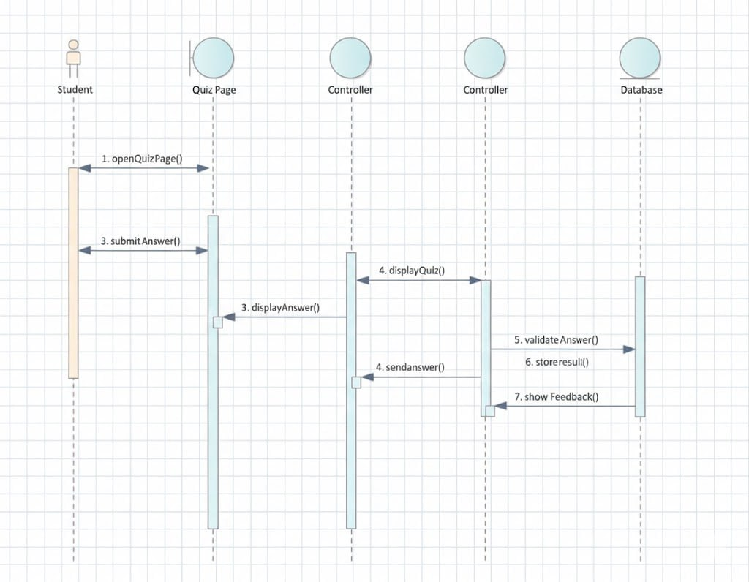

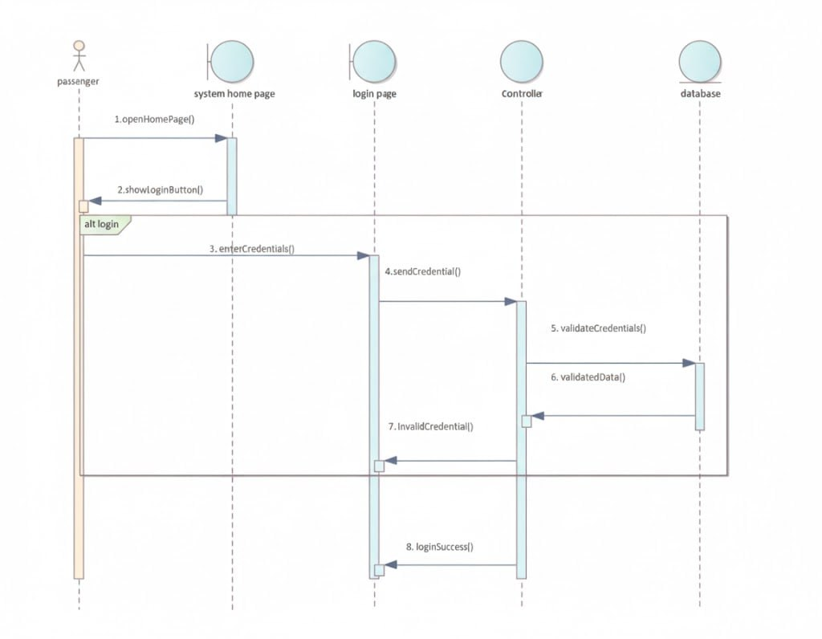

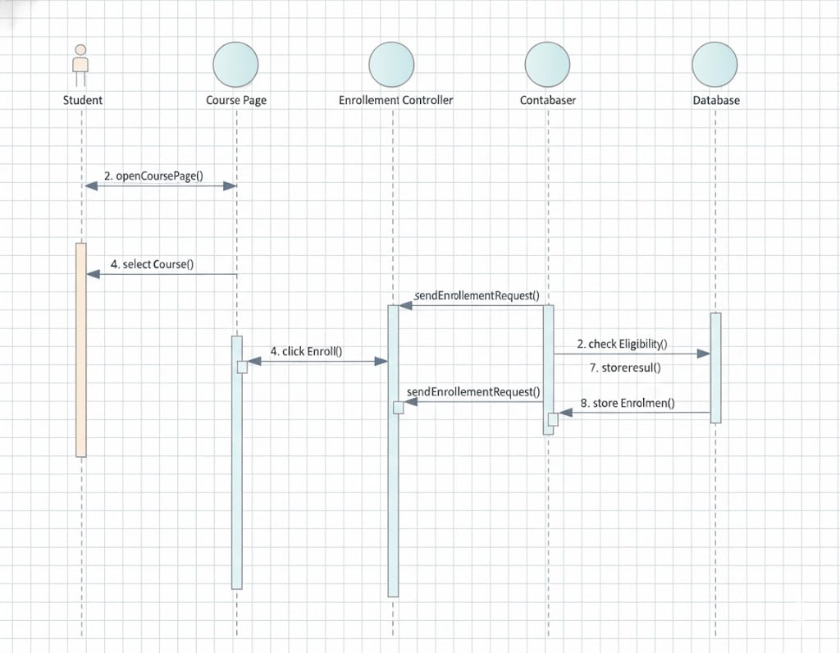

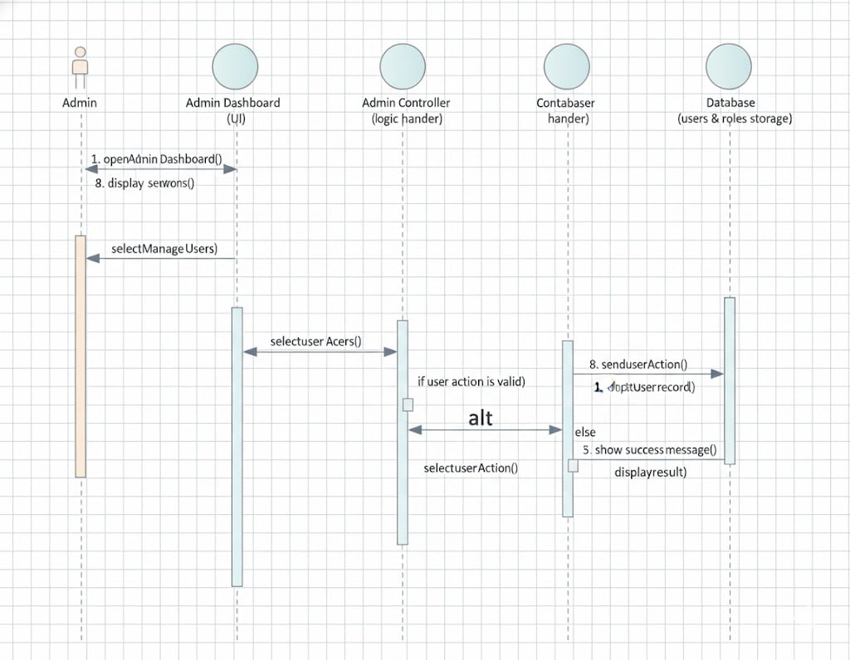

Activity diagram model

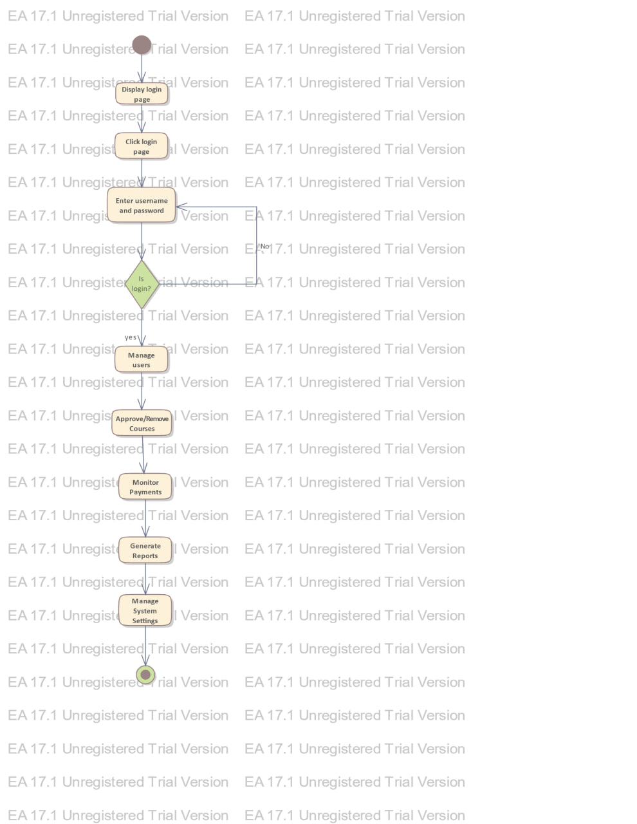

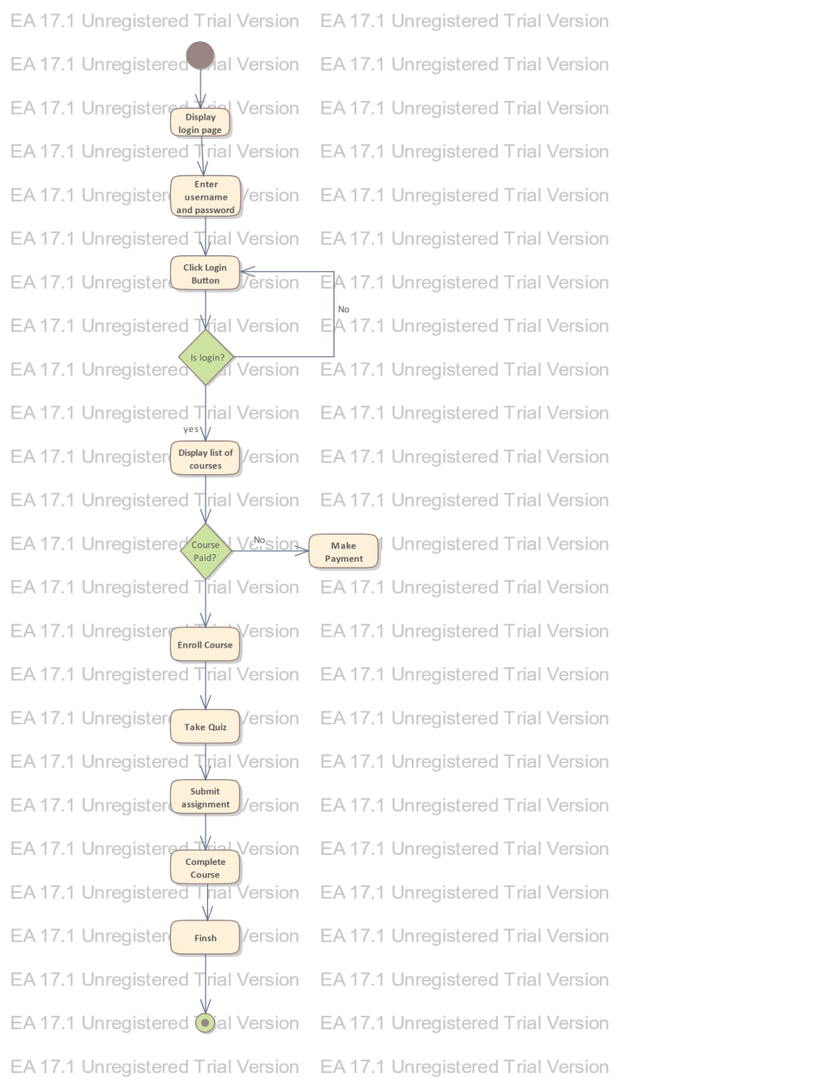

**CHAPTER FOUR**

SYSTEM DESIGN (E-LEARNING MANAGEMENT SYSTEM)

**4.1 Overview**

The design of the proposed **E-Learning Management System (ELMS)** is intended to provide a comprehensive and integrated platform for delivering online education services. The system supports core educational activities such as user registration, course management, content delivery, online assessments, student–instructor interaction, progress tracking, and reporting.

The proposed system is designed to be **user-friendly, secure, scalable, and accessible**, enabling learners, instructors, and administrators to interact effectively regardless of time and location.

**Conceptual Level Design**

The E-Learning system consists of the following major components:

* User Registration and Authentication Module
* User Profile Management Module
* Course Management Module
* Content Delivery Module
* Assessment and Evaluation Module
* Communication and Interaction Module
* Payment and Enrollment Module
* Reporting and Analytics Module

**Communication and Description of the Design**

* The **User Registration and Authentication Module** manages student, instructor, and administrator accounts, including login, role-based access control, and password recovery.
* The **Course Management Module** allows instructors to create, update, and manage courses, lessons, and learning materials.
* The **Content Delivery Module** provides access to learning resources such as videos, documents, quizzes, and assignments.
* The **Assessment and Evaluation Module** supports quizzes, exams, assignments, grading, and feedback.
* The **Communication Module** enables interaction through discussion forums, messages, announcements, and notifications.
* The **Payment and Enrollment Module** manages course enrollment and online payment transactions.
* The **Reporting and Analytics Module** generates academic and administrative reports such as student progress, course performance, and financial summaries.

All modules communicate through a **centralized database management system (DBMS)** with controlled access based on user roles. The system is designed to handle a large number of concurrent users and to scale as the number of learners and courses grows.

**4.1.1 Design Considerations and Purposes**

The design considerations and purposes of the proposed **E-Learning Management System** include the following:

**Usability**

The system is designed with a clear and intuitive user interface to ensure ease of navigation for students, instructors, and administrators.

**Scalability**

The system can accommodate an increasing number of users, courses, and learning materials without performance degradation.

**Security**

Strong security mechanisms are implemented to protect user data, course content, and payment information from unauthorized access.

**Reliability**

The system ensures consistent availability with proper testing, backup mechanisms, and error-handling strategies.

**User-Friendly Interface**

The interface is responsive and designed for accessibility across desktops, tablets, and mobile devices.

**Compatibility**

The system supports multiple operating systems, browsers, and devices to allow learning anytime and anywhere.

**Performance**

* Efficient data processing ensures fast loading of course materials.
* Optimized algorithms minimize response time.
* Infrastructure design supports high traffic during peak learning hours.

**Dependability**

* Fault-tolerant architecture ensures continuity of service.
* Secure authentication and authorization protect sensitive data.
* Error recovery mechanisms minimize system downtime.

**Maintenance**

Regular updates, system monitoring, data backups, and performance optimization are considered during the design phase to ensure long-term sustainability.

**4.1.2 Design Goals**

The primary design goal of the proposed **E-Learning Management System** is to enhance the quality and accessibility of education through digital technology.

**Specific Design Goals Include:**

* **Efficient Learning Management:** Simplify course delivery and learning processes.
* **Cost Effectiveness:** Reduce physical infrastructure and administrative costs.
* **Improved Learning Experience:** Provide personalized learning paths and progress tracking.
* **Data Security and Privacy:** Ensure confidentiality and integrity of user and academic data.
* **Accessibility:** Enable inclusive learning for users with varying technical skills.

**System Design & Code Engineering**

Class Diagram

Key Definitions & Concepts

1. What is a Class Diagram?

A Class Diagram is a static structure diagram in UML that shows:

The classes of a system

Their attributes (data/properties)

Their methods (operations/behaviors)

Relationships between classes

Purpose: To visualize the static structure of an object-oriented system before implementation.

**A. Major Classes Identification**

Definition: Core entities in your e-learning system that represent real-world objects.

Your E-Learning Classes:

text

**8. Notification**

Why These Classes?

User: Common properties for all system users

Student/Instructor/Admin: Specific user roles with unique behaviors

Course: Central entity representing educational content

Assignment/Submission/Grade: Academic workflow components

Material: Learning resources

Enrollment: Manages student-course relationships

Notification: Communication mechanism

**B. Class Components Specification**

Attributes (Properties/Fields)

Definition: Data members that store the state of an object.

Format: visibility name: type = defaultValue

**Examples:**

java

- userId: String // Unique identifier- name: String // User's full name - email: String // Contact email- password: String // Encrypted password- registrationDate: Date // When user joined- gpa: double = 0.0 // Student's GPA with default- status: String // ACTIVE/INACTIVE state

Visibility Modifiers:

•

+ = Public (accessible from anywhere)

- = Private (accessible only within class)

# = Protected (accessible within class and subclasses)

~ = Package (accessible within same package

Methods (Operations/Behaviors)

Definition: Functions that define what a class can do.

Format: visibility name(parameter: type): returnType

Examples:

java

+ login(email: String, password: String): boolean+ enrollCourse(courseId: String): boolean+ calculateGPA(): double+ getStudentById(id: String): Student

Method Components:

Name - Action verb (login, calculate, get)

Parameters - Input data with type

Return Type - Output data type

Visibility - Access level

C. Class Relationships - Detailed Explanation

**1. Inheritance (Generalization)**

Definition: "is-a" relationship where a child class inherits properties and behaviors from a parent class.

Symbol: Solid line with hollow arrow pointing to parent

Example:

text Instructor

Purpose: Code reuse and polymorphism

Implementation:

java

public abstract class User { ... }public class Student extends User { ... }public class Instructor extends User { ... }

**2. Association**

Definition: "uses-a" relationship where objects know about each other and interact.

Symbol: Solid line connecting classes

Types:

Unidirectional: One class knows about the other

Bidirectional: Both classes know about each other

Example: Student -- Course (Student enrolls in Course)

Multiplicity Notation:

1 - Exactly one

\* - Many (zero or more)

0..1 - Zero or one

1..\* - One or more

n..m - Range from n to m

Example with Multiplicity:

text

Student "1" -- "\*" Course

↑ ↑

Exactly one Can enroll in

student many cour

**3. Aggregation**

Definition: "has-a" relationship where the child can exist independently of the parent (weak ownership).

Symbol: Solid line with empty diamond at parent end

Rule: Part can exist without whole

Example: Course ◇-- Assignment

Course contains Assignments

But Assignment can exist independently (can be moved to another course)

Visual:

textgnment

Implementation:

java

public class Course {

private List<Assignment> assignments; // Aggregation}

**4. Composition**

Definition: Strong "has-a" relationship where child cannot exist without parent (strong ownership).

Symbol: Solid line with filled diamond at parent end

Rule: Part cannot exist without whole

Example: Submission ◆-- Grade

Submission has a Grade

Grade cannot exist without a Submission

If Submission is deleted, Grade is also deleted

Visual:

text Grade

Implementation:

java

public class Submission {

private Grade grade; // Composition

// Grade is created when Submission is created

// Grade is destroyed when Submission is destroyed}

1. **Relationship Comparison Table**

|  |  |  |  |  |
| --- | --- | --- | --- | --- |
| Aspect | Inheritance | Association | Aggregation | Composition |
| ****Relationship**** | "is-a" | "uses-a" | "has-a" (weak) | "has-a" (strong) |
| ****Symbol**** | Hollow arrow | Solid line | Empty diamond | Filled diamond |
| ****Life Dependency**** | Child depends on parent | Independent | Part can exist alone | Part cannot exist alone |
| ****Ownership**** | Parent owns child | No ownership | Weak ownership | Strong ownership |
| ****Cardinality**** | Always 1:1 | 1:1, 1:\*, : | 1:\*, : | 1:1, 1:\* |
| ****Example**** | Student is a User | Student takes Course | Course has Assignments | Submission has Grade |

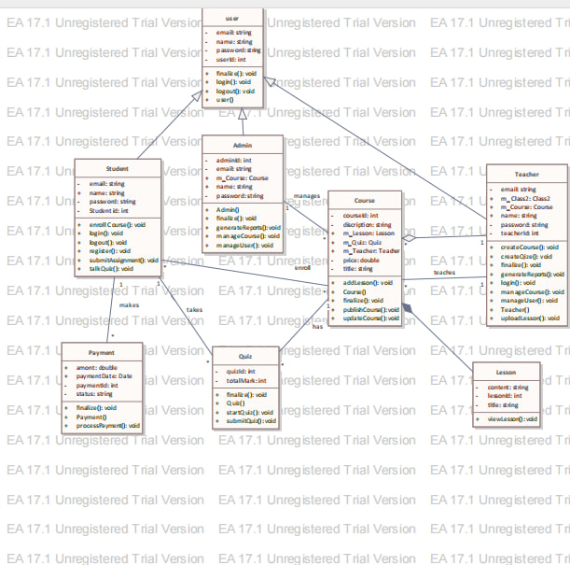

The above image shows class diagram

Forward engineering serves as the bridge between software architecture and actual implementation. In the context of your E-Learning system, it ensures that the complex relationships you modeled—such as the inheritance from the abstract **User** class to **Student** and **Instructor**—are perfectly reflected in your Java files.

### 1. How Forward Engineering Works

The process typically follows these structural transformations:

**Class to File:** Each class in your diagram becomes a .java file (e.g., Course.java, Assignment.java)

**Attributes to Fields:** The attributes you defined (e.g., String userId, int score) are converted into private or protected member variables.

**Methods to Signatures:** Your methods (e.g., enroll Course()) are generated as empty shells or "stubs," often including the correct return types and parameters.

**Relationships to Declarations:** \* **Inheritance:** Uses the extends keyword.

**Associations:** Implemented as object references or Collections (e.g., List<Course> enrolled Courses inside the Student class).

### 2. Advanced Benefits in Enterprise Architect

By using the **Forward Engineering** feature in Enterprise Architect (EA) for your project, you gain several technical advantages:

**Logic Synchronization:** If you later decide to add a new attribute to the Material class in your model, you can re-run the generator to update the code without manually editing the file.

**Standardized Headers:** EA can automatically insert file headers, copyright notices, and "Unregistered Trial Version" metadata (matching your uploaded document style) into every generated source file.

**Support for Multiple Languages:** While you are likely using Java, the same model can be used to generate C#, C++, or PHP code if the project requirements change.

### 3. Step-by-Step Implementation Guide for your Project

To move from your model to code in Enterprise Architect:

**Select the Package:** In the Project Browser, right-click the package containing your Class Diagram.

**Code Generation Menu:** Navigate to **Develop > Source Code > Generate > Generate All**.

**Configure Options:** Set the target language to **Java** and choose your output directory (typically a /src folder in your repository).

**Review the Output:** Open the generated files in an IDE (like IntelliJ or VS Code). You will see your classes, attributes, and relationship logic ready for the implementation of business logic.

### 4. Maintaining the Design-Code Loop

Forward engineering is most effective when paired with **Reverse Engineering**. If you write logic in the code that changes the structure, you can sync those changes back to your diagram, ensuring your documentation in the docs/ folder never becomes obsolete.

**Forward Engineering**

Admin.java

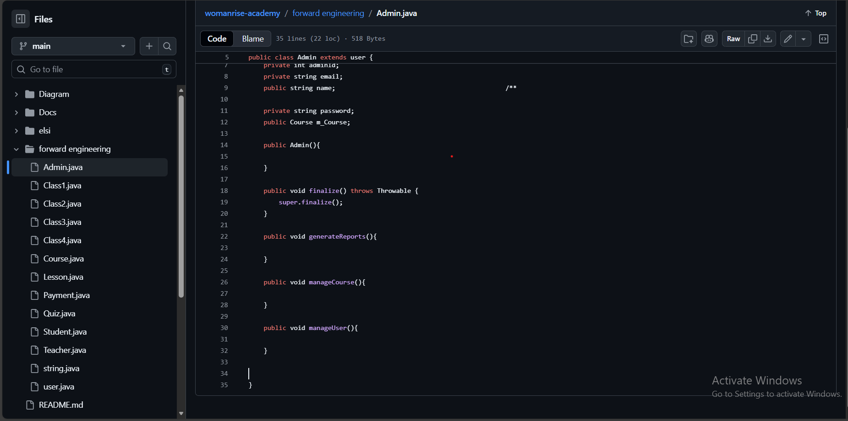

Course.java

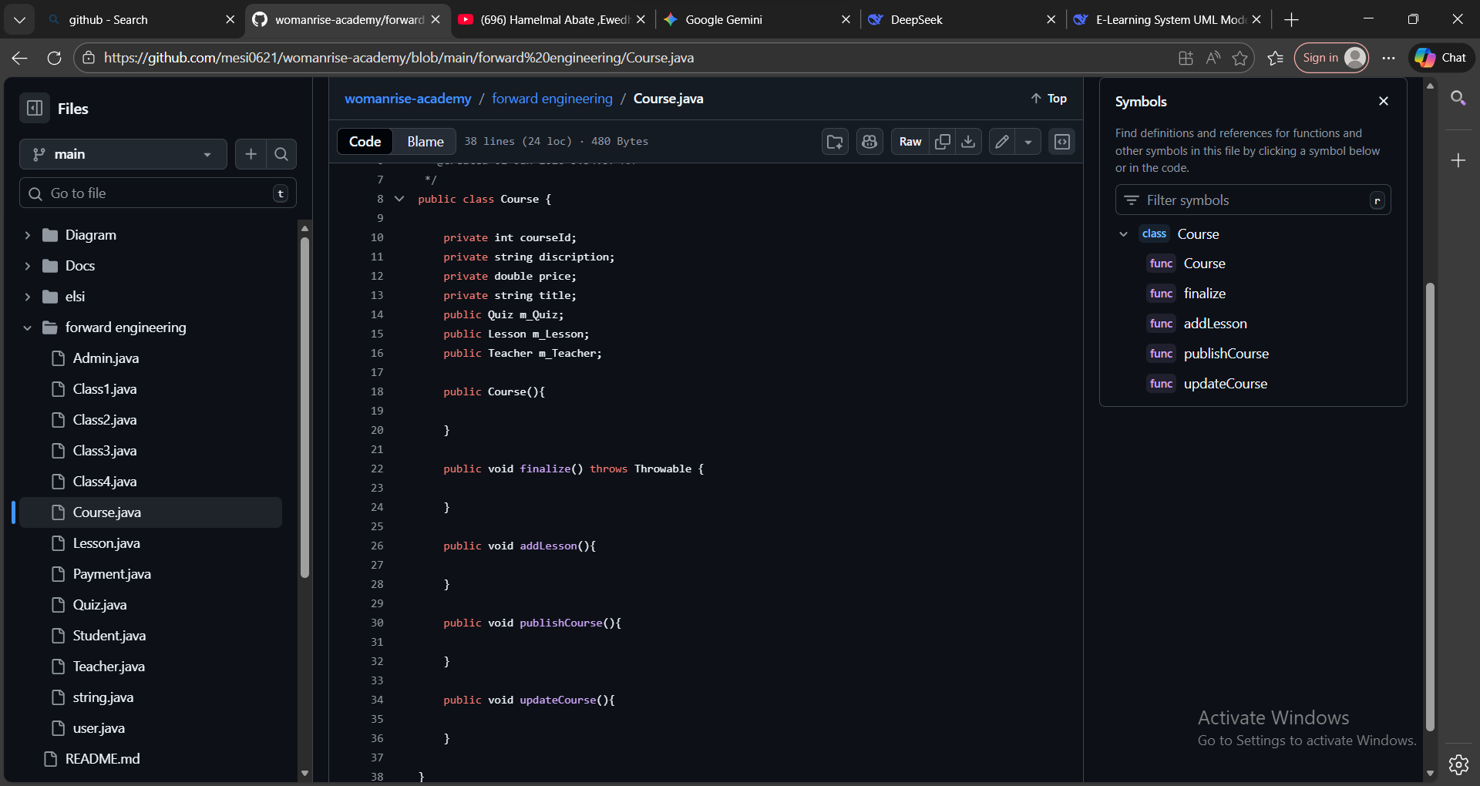

Payment.java

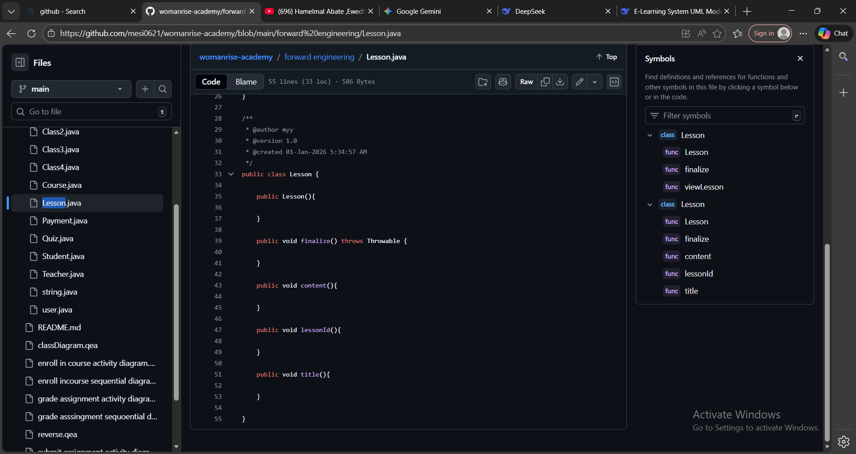

Quize.java

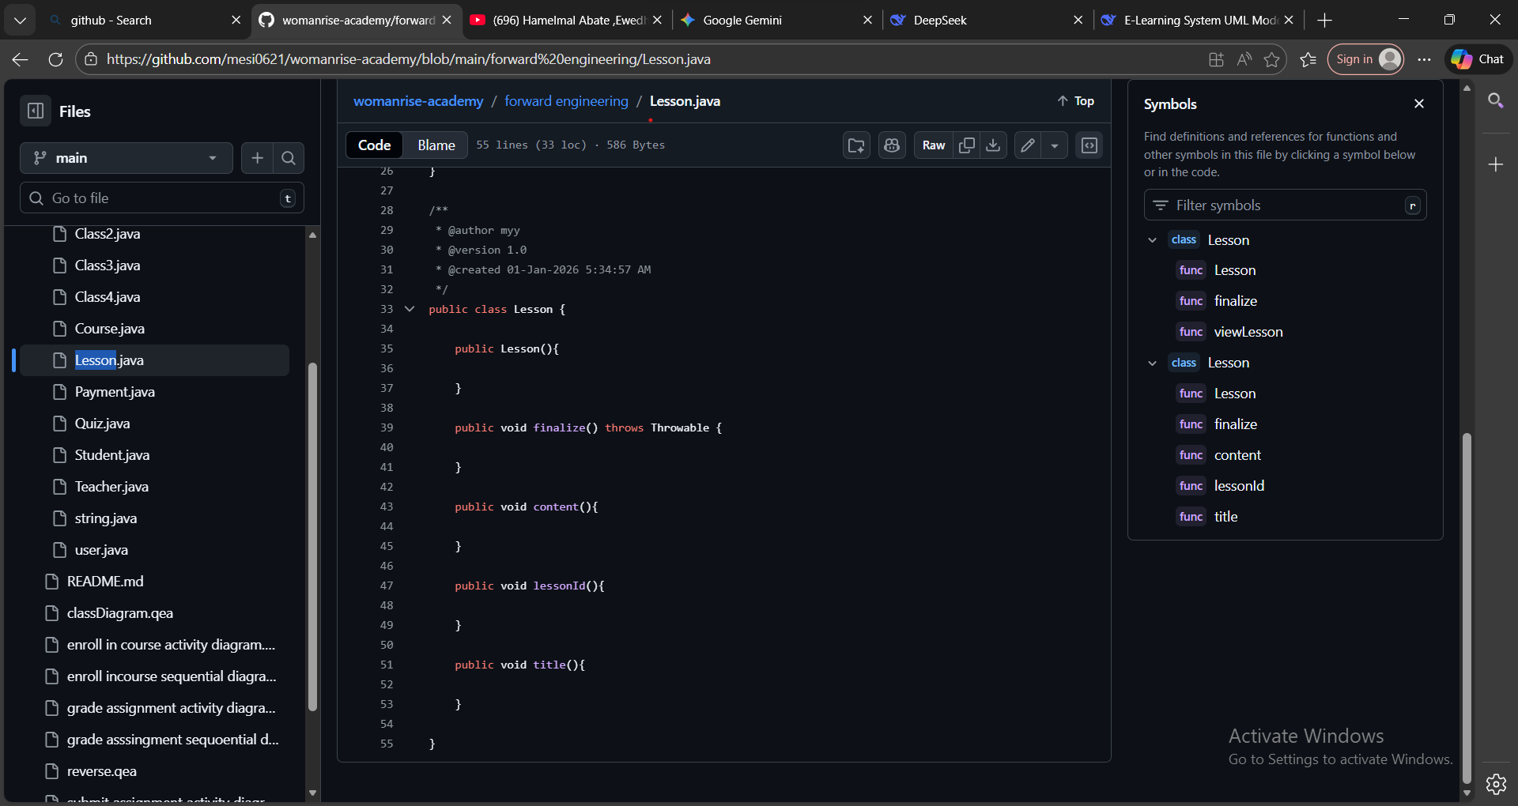

Student.java



Teacher.java

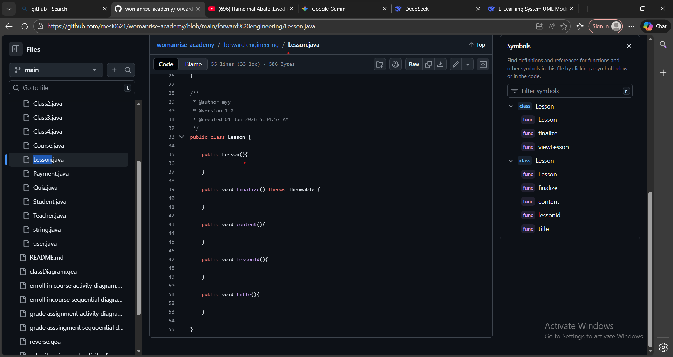

User.java



**Reverse Engineering: Code → Model**

**Reverse Engineering**

Reverse engineering is the process of analyzing existing software code to create or update its visual design model (UML diagram). It works in the opposite direction of normal development.

Simple Definition:

Taking finished code → Creating/Updating design diagrams

How It Works: Start with completed or modified source code

Use a tool (like Enterprise Architect) to analyze the code structure

Automatically generate or update UML diagrams from the code

The diagrams now match the actual implementation

Example:

Your Java code has:

java

public class Student {

private String id;

private String name;

// Constructor added manually

public Student(String id, String name) {

this.id = id;

this.name = name;

}}

Reverse engineering reads this code and updates the UML diagram to show:

The Student class

Its attributes: id, name

Its constructor: Student(id, name)

Why It's Useful:

Documentation: Creates diagrams from existing code

Synchronization: Keeps diagrams up-to-date with code changes

Analysis: Helps understand unfamiliar codebases

Modernization: Updates old designs when refactoring code

* 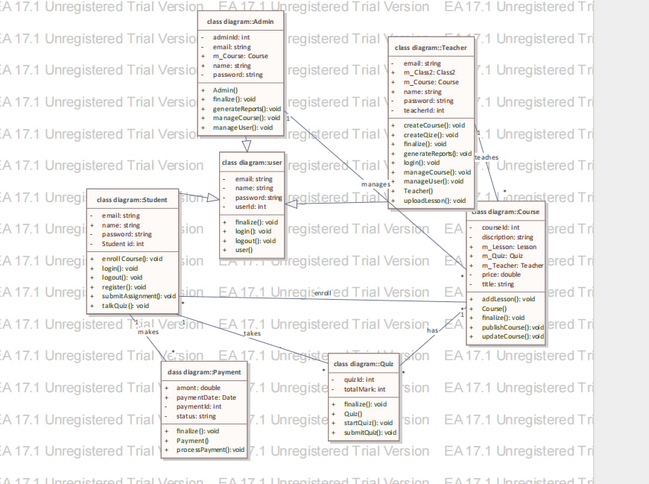

### **High-Level Design (HLD)**

The HLD provides the "big-picture" of how the system components interact and how data flows between them.

#### **1. System Architecture Diagram**

The system follows a **3-Tier Architecture**:

**Presentation Tier:** Web/Mobile UI for Students, Instructors, and Admins.

**Application Tier:** Logic for enrollment, grading, and content management.

**Data Tier:** PostgreSQL/MySQL Database and File Storage.

#### **2. Module Diagram**

The system is divided into five core modules:

**User Management:** Handles authentication and profiles.

**Course Module:** Manages course creation and enrollment logic.

**Assessment Module:** Handles assignment submissions and grading.

**Notification Module:** Dispatches emails/alerts to users.

**Payment Module:** Interfaces with external gateways.

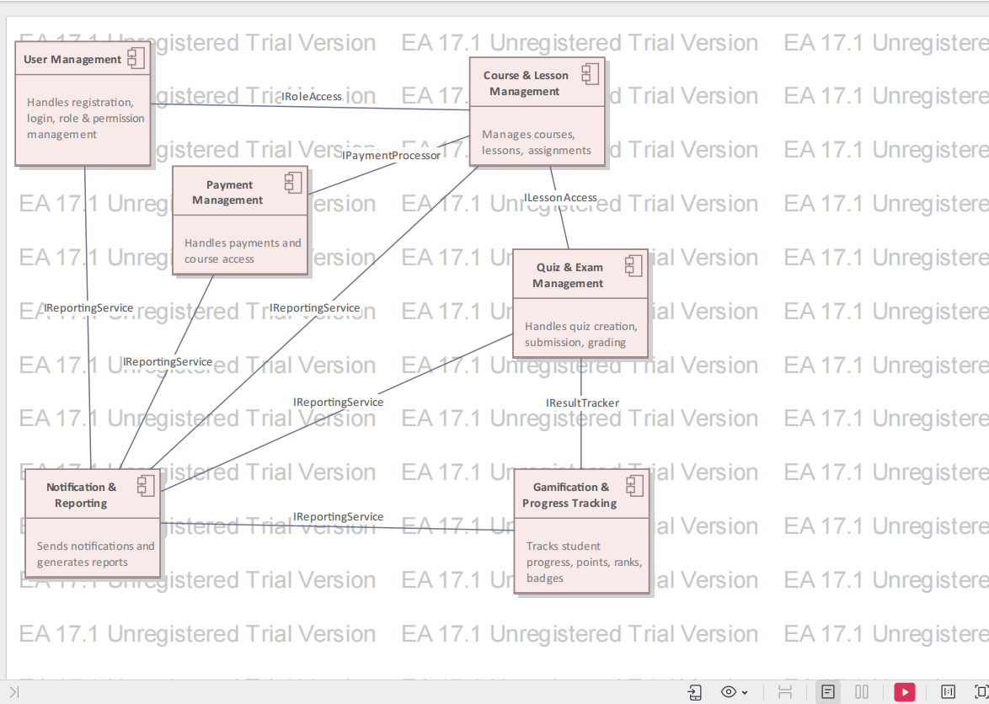

#### **Data Flow Diagram (DFD - Level 1)**

**Input:** User credentials, course selections, and assignment files.

**Process:** The system validates data, updates records, and triggers notifications.

**Output:** Enrollment confirmations, grade reports, and syllabus updates.

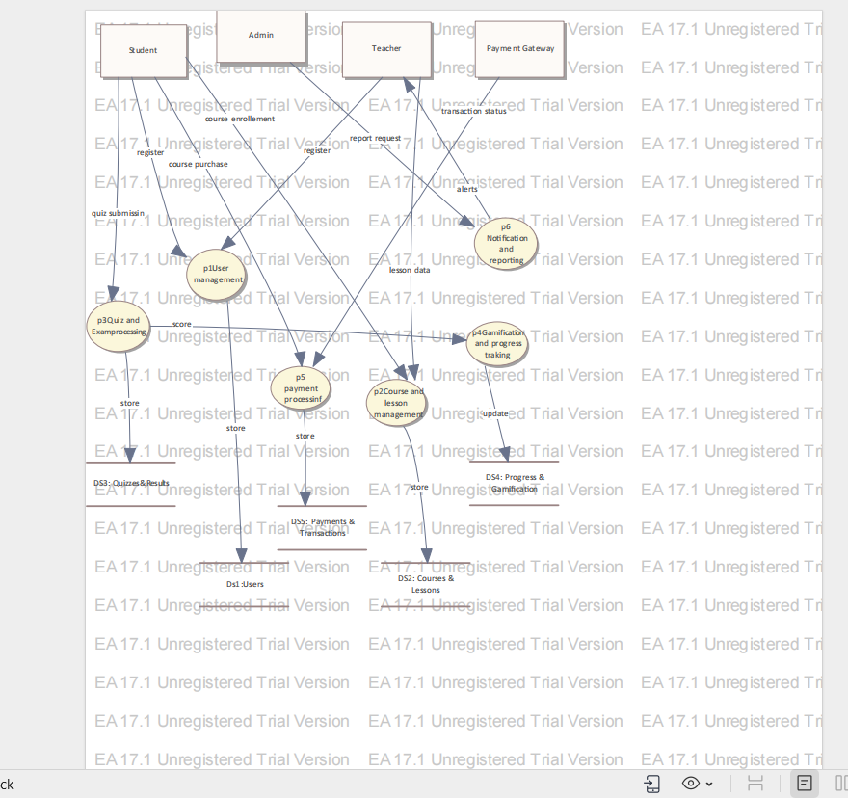

#### **4. High-Level Database Schema**

A simplified view of the primary entities: Users, Courses, Enrollments, Assignments, and Grades.

a **High-Level Database Schema** serves as a conceptual map of how your system stores and relates its most important information. Unlike a detailed database design that lists every technical detail, the high-level view focuses on the "Big Picture" entities and how they are connected.

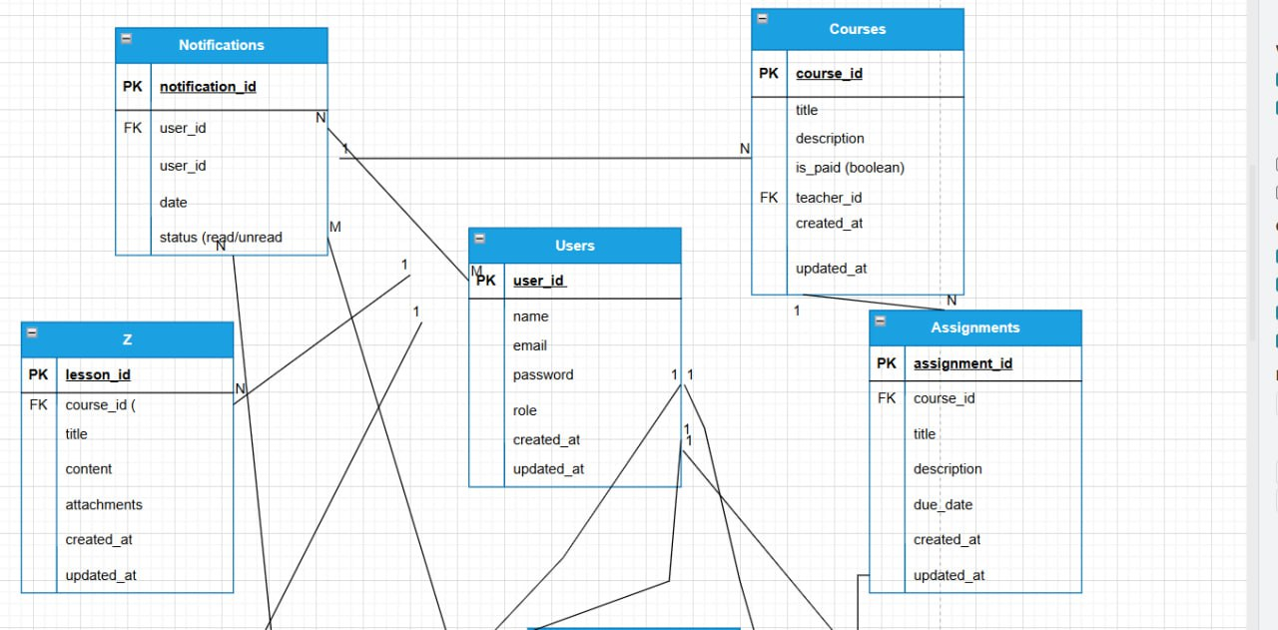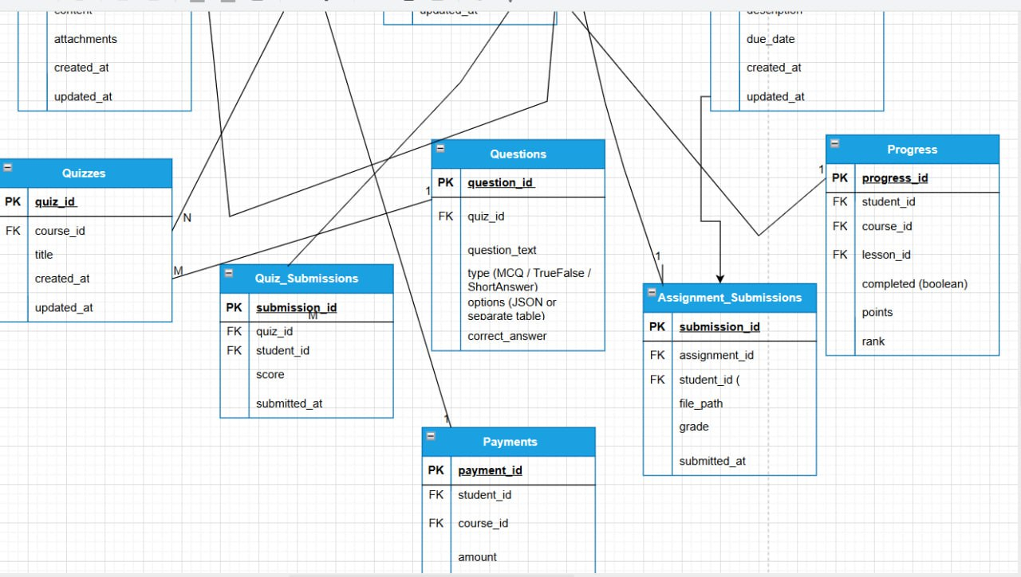

Here is a breakdown of what those specific entities mean for your E-Learning system:

### 1. The Core Entities

**Users:** The central table storing identity and access credentials. In your system, this includes the **Student**, **Instructor**, and **Admin** roles.

**Courses:** The container for all educational content. This entity stores the course title, description, and the instructor assigned to lead it.

**Enrollments:** This is a "bridge" entity that links **Users (Students)** to **Courses**. It tracks who is taking which course and their current status (e.g., Active or Completed).

**Assignments:** These are specific tasks or assessments created within a **Course**. They contain metadata like the due date and maximum possible points.

**Grades:** This entity records the outcome of a student's performance. It links a specific **User (Student)** to a specific **Assignment** and stores the score and feedback.

### 2. How the Data Moves (Relationships)

The high-level schema explains the logic of your system's data:

**One-to-Many (1:N):** One **Instructor** (User) can manage many **Courses**. One **Course** can have many **Assignments**.

**Many-to-Many (M:N):** Many **Students** can enroll in many **Courses**. This is why the **Enrollments** table exists—to sit in the middle and manage those complex connections.

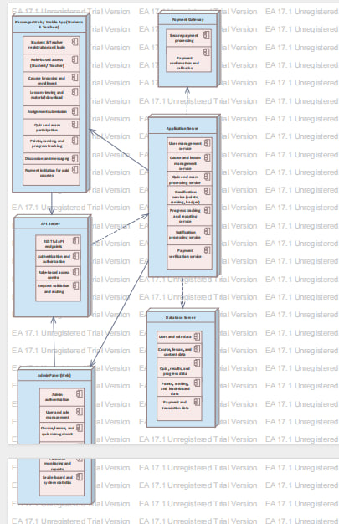

### 3,Why This Is Part of HLD

In the High-Level Design phase, you use this schema to:

**Validate Requirements:** Ensure you have a place to store all the data needed for your functional requirements (like grading or enrollment).

**Guide Development:** Inform the developers which primary tables need to be created first before they start writing the low-level code or complex queries.

**Visual Consistency:** Since you are using **Enterprise Architect**, this schema would be presented with the same light beige/yellow boxes and the "EA 17.1 Unregistered Trial Version" watermark seen in your documentation to maintain a professional, unified loo

### **Part 2: Low-Level Design (LLD)**

LLD focuses on the internal logic and implementation details of the components identified in the HLD.

#### **1. Class Diagram & Method Definitions**

Refining the classes with specific logic:

**Course**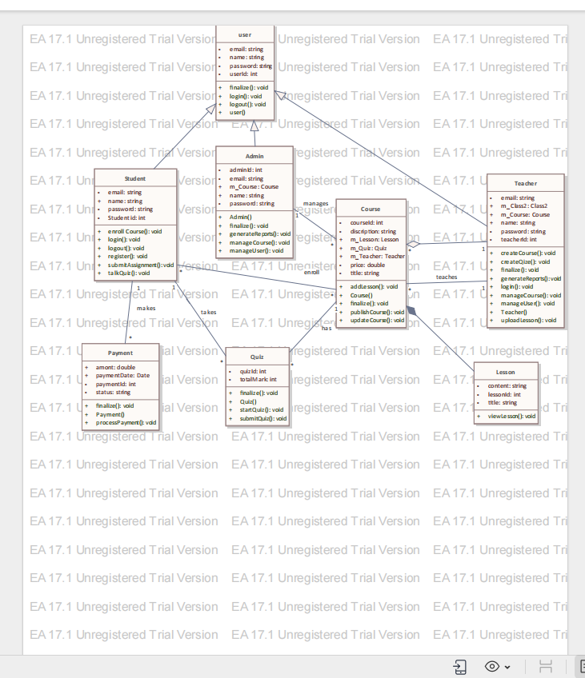

**Manager**: checkPrerequisites(studentId, courseId): boolean

**AssignmentValidator**: isValidFormat(file): boolean, isWithinDeadline(timestamp): boolea

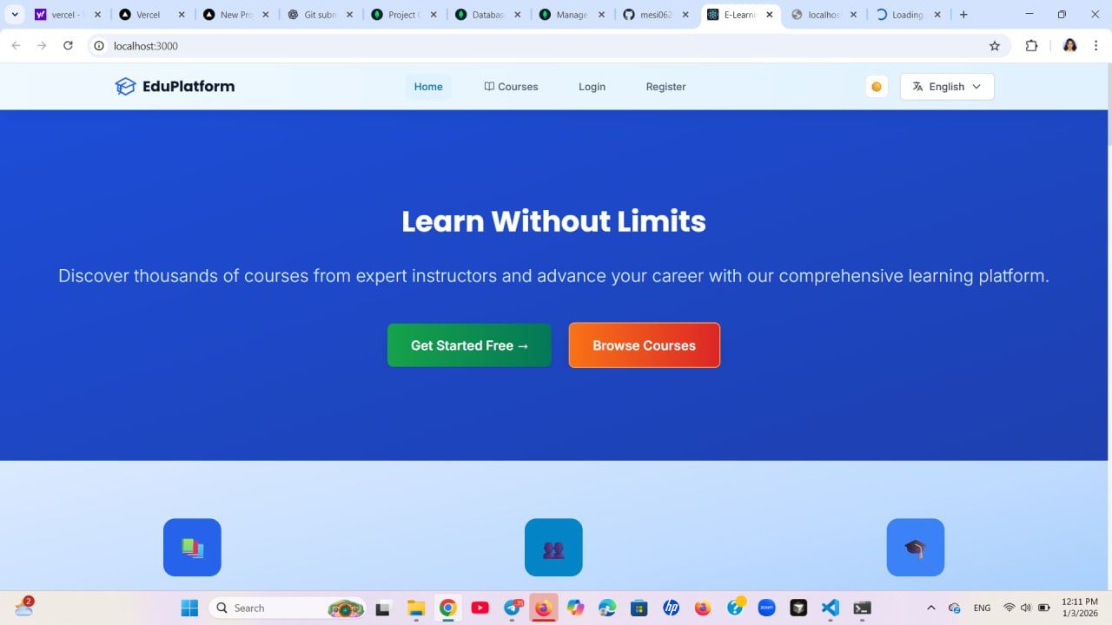

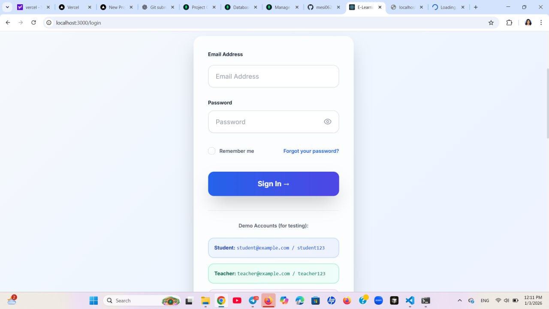

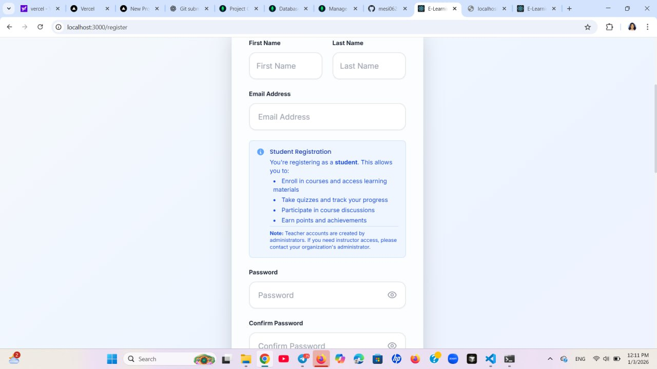

#### 

#### **2.Pseudocode / Algorithms**

**Enrollment Logic Algorithm:**

Plaintext

IF student.isLoggedIn() AND course.hasSeats() THEN

PROCESS payment via PaymentModule

IF payment.isSuccessful() THEN

CREATE enrollment record in Database

NOTIFY student via NotificationService

ELSE

RETURN "Payment Failed"

END IF

ELSE

RETURN "Enrollment Denied"

END IF

#### **3. Detailed Database Tables**

| **Table** | **Columns** | **Constraints** |
| --- | --- | --- |
| **Users** | id (PK), email (Unique), password\_hash, role | Admin manages roles |
| **Submissions** | id (PK), student\_id (FK), asgn\_id (FK), file\_path | Linked to File Manager |

#### **4. Sequence Diagrams**

These diagrams detail the step-by-step object interactions for specific use cases, such as "Submit Assignment" or "Process Payment," using green arrows for messages and brown arrows for start/end triggers.

#### **5. Error Handling and Validations**

**Input Validation:** Sanitize all user inputs to prevent SQL Injection.

**File Constraints:** Limit assignment uploads to specific formats (PDF, DOCX) and size (10MB).

**Exception Handling:** Database Connection Exception: Triggers a retry mechanism.

Authentication-exception: Redirects to the login page.

## Unit Testing with J Unit (Java)

**Unit Testing** is the practice of testing the smallest testable parts of an application (called units), such as individual **methods or classes**, to ensure they work correctly.  
**JUnit** is the most widely used **unit testing framework for Java**.

## Purpose of Unit Testing

To verify that each unit of code behaves as expected.

To test code **in isolation**, independent of other components.

To ensure correctness before integration.

## How Unit Testing Works in J Unit

Write test methods for your Java code.

Call the target method with known inputs.

Compare the actual output with the expected output using **assertions**.

J Unit automatically runs tests and reports pass/fail results.

## Benefits of Using JUnit

✅ **Catches bugs early** in development

✅ **Improves code quality and reliability**

✅ **Allows safe refactoring** without fear of breaking functionality

✅ **Acts as documentation** for how methods should behave

✅ **Saves time** in long-term maintenance

## 

## Basic JUnit Test Example

@Testpublic void testAddition() {

Calculator calc = new Calculator();

int result = calc.add(2, 3);

assertEquals(5, result); // Assertion

}

### Explanation

@Test → Marks the method as a test case

calc.add(2, 3) → Calls the method being tested

assertEquals(5, result) → Checks if the result is correct

If the result is **not 5**, the test **fails**.

## Common JUnit Annotations (JUnit 5)

|  |  |
| --- | --- |
| **Annotation** | **Description** |
| @Test | Marks a test method |
| @BeforeEach | Runs before each test (setup) |
| @AfterEach | Runs after each test (cleanup) |
| @BeforeAll | Runs once before all tests |
| @AfterAll | Runs once after all tests |

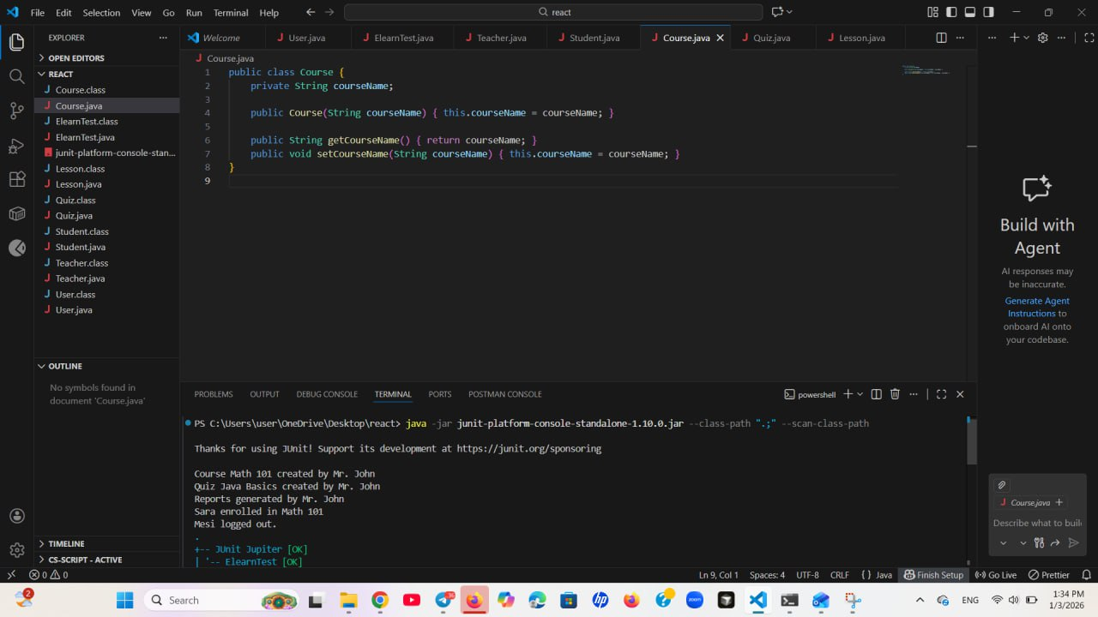

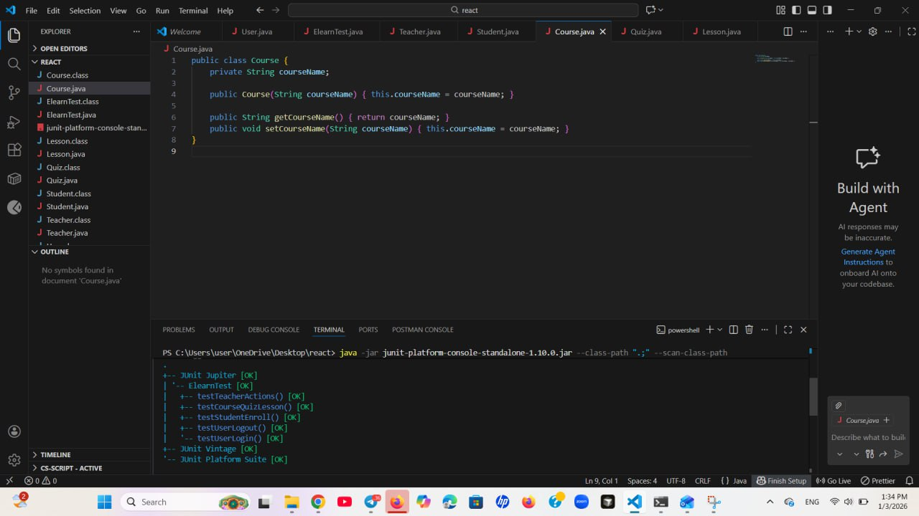

**4.1.3 Design Guidance and Issues**

**Design Guide for E-Learning Management System**

1. **Understand Educational Requirements:** Analyze the needs of learners, instructors, and administrators.
2. **Identify Core Modules:** User management, course management, assessments, and communication.
3. **Develop a Data Model:** Represent relationships between users, courses, content, and assessments.
4. **Select Technology Stack:** Choose scalable, secure, and user-friendly technologies.
5. **Design User Interface:** Create visually appealing and intuitive layouts.
6. **Implement Modular Architecture:** Develop and test each module independently.
7. **User Training:** Provide documentation and training materials for system users.

**4.2 Proposed System Architecture**

The proposed E-Learning system follows a **multi-layered architecture**, which includes:

**Presentation Layer**

Provides the graphical user interface (web pages, dashboards, forms) accessed through web browsers and mobile devices.

**Application Layer**

Contains the business logic for course management, assessments, enrollment, and communication.

**Database Layer**

Stores all system data such as user profiles, courses, learning materials, grades, and payment records.

**Security Layer**

Ensures secure authentication, authorization, encryption, and protection against cyber threats.

**Infrastructure Layer**

Includes servers, hosting services, networking components, and cloud infrastructure required to operate the system.

**Figure:** System Architecture of Proposed E-Learning Management System

**4.2.1 System Process**

The system design process includes:

* Requirement gathering and analysis
* System architecture design
* Documentation of design specifications
* Design review and validation
* System implementation
* Testing and quality assurance
* Deployment and maintenance

**4.2.2 Subsystem Decomposition**

The E-Learning system is decomposed into the following subsystems:

* User Management Subsystem
* Course Management Subsystem
* Content Delivery Subsystem
* Assessment Subsystem
* Communication Subsystem
* Payment and Enrollment Subsystem
* Reporting Subsystem

Each subsystem is further divided into modules to achieve overall system functionality.

## System Decomposition

The E-Learning Management System is decomposed into five primary subsystems, each responsible for a specific domain of the platform’s functionality.

### 1. User Management Subsystem

This module handles all identity and access management.

**Registration/Login:** Support for multi-role signups (Student, Instructor, Admin).

**Profile Management:** Capability for users to update biographies, profile pictures, and contact info.

**Authentication & Authorization:** Role-based access control (RBAC) and OAuth integration.

### 2. Content Management Subsystem (CMS)

The core engine where educational material is created and stored.

**Course Creator:** Tools for instructors to build modules, lessons, and topics.

**Media Library:** Management of video files, PDFs, and slide decks.

**Resource Versioning:** Ensuring students always have access to the latest curriculum updates.

### 3. Learning & Engagement Subsystem

Focuses on the active "classroom" experience for the student.

**Video Streaming Engine:** Adaptive bitrate streaming for various internet speeds.

**Interactive Quiz Engine:** Logic for timed assessments, automated grading, and feedback.

**Discussion Forums:** Peer-to-peer and student-to-teacher communication threads.

**Assignment Module:** Handling file uploads for homework and manual grading interfaces.

### 4. Administrative & Analytics Subsystem

The "Back-office" tools used to monitor platform health and progress.

**Data Dashboard:** Visualizing enrollment trends and completion rates.

**Financial Module:** Tracking revenue, instructor payouts, and discount coupons.

**User Support:** Ticketing system for technical issues.

### 5. Notification & Integration Subsystem

The bridge between the platform and the outside world.

**Messaging Service:** Automated emails and push notifications for course updates.

**API Gateway:** Managing connections to external tools like Zoom (Live classes) and Stripe (Payments).

### Decomposition Table (High-Level Summary)

| **Subsystem** | **Primary Function** | **Data Handled** |
| --- | --- | --- |
| **Frontend UI** | User Interaction | User Inputs, Display Logic |
| **Logic Layer** | Processing Requests | Business Rules, Grading Logic |
| **Storage Layer** | Persistent Data | User Records, Course Content |
| **Media Layer** | Video/File Hosting | Large Binary Objects (MP4, PDF) |

### Visual Representation (Functional Flow)

**Input:** User credentials or Course content.

**Process:** Validation $\rightarrow$ Storage $\rightarrow$ Transformation (e.g., video transcoding).

**Output:** Certificates, Grade reports, or Streaming content.

### 4.2.3 Hardware/Software mapping

Hardware components:

* Servers
* Computer
* Storage devices
* Networking components (such as routers, switches, and firewalls)

Software components:

* Operating systems (like Windows)
* Databases management system (MySQL)
* Run-time Environment (XAMPP server)
* Programming languages
* Security software (such as antivirus software and firewalls)

**4.2.4 Persistent Data Management**

Persistent data in the proposed E-Learning system includes user accounts, course materials, assessments, grades, and transaction records.

The system uses a robust DBMS that supports:

* Data backup and recovery
* Secure data access
* Scalability and performance optimization

Security measures such as encryption, access control, and audit logging are implemented to protect stored data.

**4.3 Design Control**

* **Configuration Control:** Tracks system changes and version history.
* **Design Input Verification:** Ensures system requirements are correctly implemented.
* **Design Verification:** Confirms the system meets quality and functional standards.
* **Design Output Quality:** Enforces rigorous testing and validation.
* **Change Control:** Manages updates through structured approval and version control mechanisms.

## 4.4 Low-level design model

### 4.4.1 State chart diagram

### 4.4 Low-Level Design Model

The low-level design focuses on the internal logic of individual modules. It translates functional requirements into a detailed blueprint that developers use for coding state transitions and data validation.

### 4.4.1 State Chart Diagram: Course Enrollment & Progress

This diagram tracks the "State" of a course from the moment a student interacts with it until they finish it.

#### Description of States:

**Available:** The course is published and visible in the catalog but not yet purchased/joined.

**Enrolled/Started:** The student has registered for the course. The progress counter is initialized at $0\%$.

**In-Progress:** The student is actively consuming content. The system transitions to this state whenever a video is played or a document is opened.

**On-Hold/Paused:** Triggered if a subscription expires or if the user manually pauses their learning.

**Assessment-Pending:** The student has finished all lessons and is currently taking the final quiz or awaiting assignment grading.

**Completed:** The final state where the progress reaches $100\%$. This state triggers the **Certificate Generation** logic.

#### State Transition Logic Table

| **Current State** | **Event (Trigger)** | **Target State** | **Action Taken by System** |
| --- | --- | --- | --- |
| **Available** | Click "Enroll" | **Enrolled** | Create record in student\_courses table. |
| **Enrolled** | Open Lesson 1 | **In-Progress** | Start tracking time spent/progress. |
| **In-Progress** | Submit Final Exam | **Assessment-Pending** | Lock lesson content; notify Instructor. |
| **Assessment-Pending** | Grade $\ge$ Passing Score | **Completed** | Generate PDF Certificate. |
| **Assessment-Pending** | Grade $<$ Passing Score | **In-Progress** | Reset quiz attempt; provide feedback. |

### photo_2026-01-04_08-42-00

### 

### 4.4.2 State Chart Diagram: Instructor Content Upload

Additionally, the **Content Upload** process follows its own state machine to ensure quality control:

**Draft:** Content is being edited by the instructor (not visible to students).

**Under Review:** Content is submitted for admin approval (if proctored).

**Published:** Content is live for learners.

**Archived:** Content is outdated and hidden from the catalog.

### photo_2026-01-04_08-39-09

**4.6 Boundary Conditions and Access Control**

The proposed **E-Learning Management System (ELMS)** has clearly defined boundary conditions that determine its scope, functionality, and the categories of users authorized to access the system. These boundary conditions are established based on the educational institution’s objectives, user roles, and data protection requirements.

The system enforces a boundary condition that **only authorized users such as students, instructors, and administrators** can access learning content, assessments, and user data. Unauthorized users are restricted from accessing protected resources such as course materials, grades, and payment records.

The proposed **E-Learning Management System** exhibits the following quality attributes of a system under development:

* **Modifiable:**  
  The system is designed to allow easy modification without affecting the overall structure. This is essential because educational requirements, teaching methods, and curriculum content may evolve over time.
* **Re-place-ability:**  
  System components such as payment gateways, content delivery modules, or assessment tools can be replaced with compatible alternatives without major redesign.
* **Re-usability:**  
  System modules such as user authentication, course management, and reporting can be reused in other educational platforms or future projects.
* **Extensibility:**  
  The system supports the addition of new features such as live virtual classrooms, AI-based recommendations, or mobile learning support without extensive code changes.
* **Maintainability:**  
  The system architecture supports easy maintenance, debugging, and updates, ensuring long-term operational efficiency.

**4.6.1 Access Control Mechanisms**

Access control mechanisms are implemented in the proposed **E-Learning Management System** to ensure that system resources are accessed only by authorized users. These mechanisms include:

**User Authentication**

Only registered users can access the system. Users must log in using valid credentials such as username and password before accessing any system functionality.

**Role-Based Access Control (RBAC)**

The system applies role-based access control to ensure users access only the information relevant to their role:

* **Students:** Access enrolled courses, learning materials, assessments, and grades.
* **Instructors:** Create and manage courses, upload content, evaluate assessments, and interact with students.
* **Administrators:** Manage users, courses, payments, and system configuration.

Each role is assigned specific permissions that define allowed actions within the system.

**Data Encryption**

All sensitive data such as user credentials, assessment results, and payment information are encrypted to ensure confidentiality and data integrity. Passwords are stored using secure hashing techniques to prevent unauthorized access.

**Access Restrictions**

Access to certain features and data is restricted based on authorization level. For example, students cannot modify course content, and instructors cannot access administrative financial data unless permitted.

**4.7 Conclusion and Recommendation**

**4.7.1 Conclusion**

An **E-Learning Management System** is a web-based software solution that facilitates the delivery, management, and evaluation of online education. The implementation of the proposed E-Learning system significantly improves the accessibility, flexibility, and efficiency of educational services.

The system automates core academic processes such as course delivery, student enrollment, assessments, grading, and progress tracking. This automation reduces manual workload, minimizes errors, and ensures accurate record keeping.

Furthermore, the system enhances learning outcomes by providing learners with continuous access to educational resources and enabling effective communication between students and instructors. It also supports institutional decision-making through comprehensive reporting and analytics.

Overall, the proposed E-Learning Management System contributes to improved educational quality, operational efficiency, and user satisfaction. By replacing traditional manual processes with a digital platform, the system ensures a more scalable, reliable, and modern learning environment.

**4.7.2 Recommendation**

The developed system is a **web-based E-Learning platform** designed to support online teaching and learning activities. During the development process, the project team encountered various technical and organizational challenges. However, through teamwork and collaboration, the system was successfully implemented.

The proposed E-Learning system is carefully designed to meet the academic and administrative needs of educational institutions. Data security and user privacy were given high priority throughout the design and implementation phases.

It is recommended that:

* Adequate training be provided to instructors and administrators to ensure effective system usage.
* Technical support services be established to handle system maintenance and user assistance.
* Continuous system evaluation be conducted to improve performance and user experience.

**Possible Future Improvements**

The system can be enhanced in the future by adding additional modules such as:

* Learning analytics and performance prediction
* Mobile application integration
* Live video conferencing and virtual classrooms
* AI-based personalized learning recommendations
* Content plagiarism detection and proctoring systems

These enhancements would further improve the effectiveness and scalability of the E-Learning platform.

**4.8 References**

* Dennis, A., Wixom, B. H., & Tegarden, D. (2010). *System Analysis and Design with UML Version 2.0: An Object-Oriented Approach* (3rd ed.). John Wiley & Sons.
* Silberschatz, A., Korth, H. F., & Sudarshan, S. *Database System Concepts* (6th ed.).
* Jalote, P. *An Integrated Approach to Software Engineering* (3rd ed.).
* Sommerville, I. *Software Engineering* (10th ed.).
* Pressman, R. S. *Software Engineering: A Practitioner’s Approach*.